Project Name - MP Police
Installation Of rocket chat server
Last Updated : 27th November 2023
Prepared By
Tetra Information Services Pvt. Ltd, Team

CAUTION
This document is released by Tetra Information Services Pvt. Ltd
The information contained in this document is confidential and no part of this document may be reproduced, stored in a retrieval system or transmitted in any form or by any means, electronic, mechanical, photocopying, recording or otherwise, without the prior written consent.

Document Control
Document No | Tetra_Doc3
Version No | 6.2.11
Prepared By | Tetra Information Services Pvt. Ltd
Release Date | 27th November 2023

Revision Control Information
File Name : Rocketchat Server Installation .pdf

S.No | Section No | Nature of Amendment | Document Version No | Document Release Date | Remarks
1 | All | Initial | 6.2.11 | 3rd November 2023 | RocketChat Installation

Table of Contents
1 Installation of rocket chat server
1.1
1.2
2 Dos and Donts of rocket chat server
3 FAQ
3.1 Instalation
3.1.1 Heading2.1.1

Installation Of RocketChat server
OS- Version Ubuntu 22.04.3 LTS

# nmtui
- To Set permanent hostname

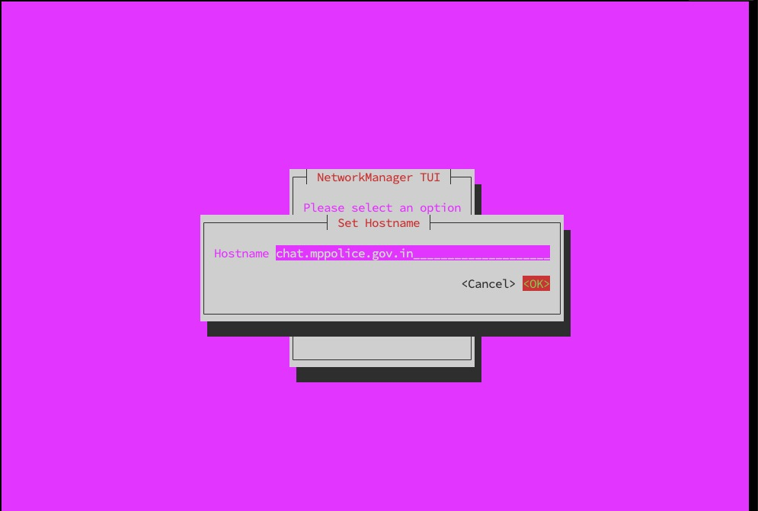

# curl -L https://get.docker.com | sh
- To Download Docker and Docker Compose

# docker info
-To check docker information

# systemctl status docker
-To check docker status, Running or Not

# systemctl restart docker
-To restart the docker service

# systemctl status docker
-To check docker status, Running or Not

# sudo usermod -aG docker mppolice
-Added mppolice user in Docker group

# docker compose version
-To check the docker version
Docker Compose version v2.21.0

# sudo apt install docker-compose-plugin
-To Install docker plugin

# mkdir rocketchat
-Create a dirctory named rocketchat

# cd rocketchat/
-Change dirctory to rocketchat and create 2 directory which is mention below

# vi compose.yml
-Create a file named <compose.yml> and apply parameter accordingly

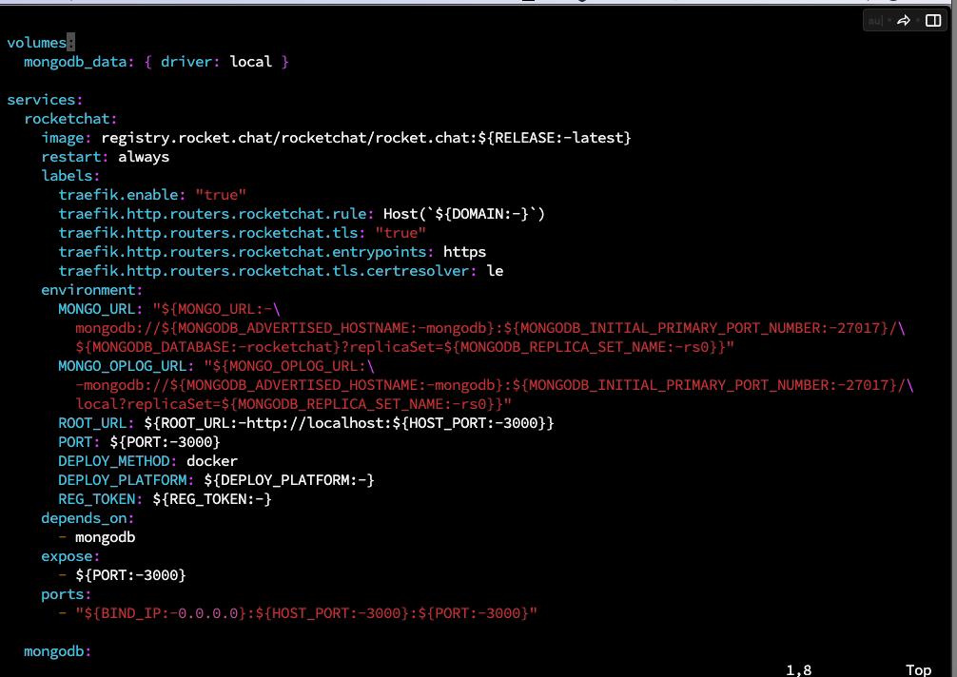

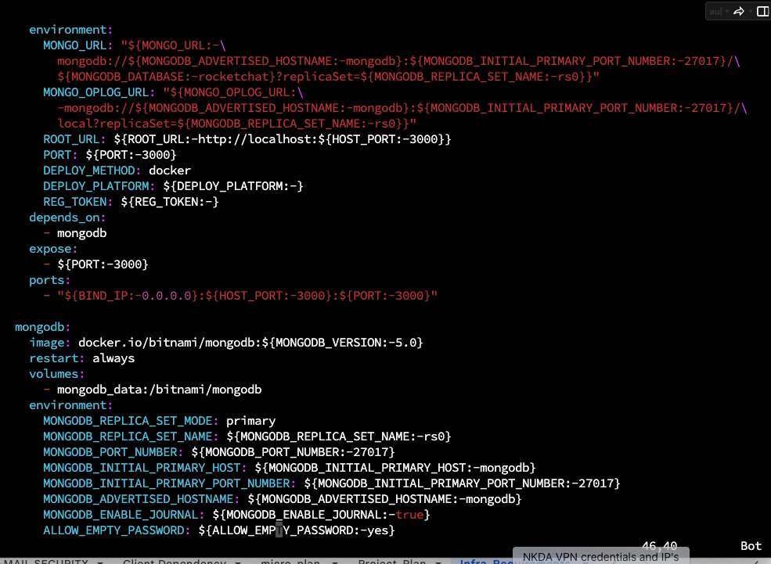

# Vi .env
-Create a hidden file named <.env > and apply parameter accordingly.

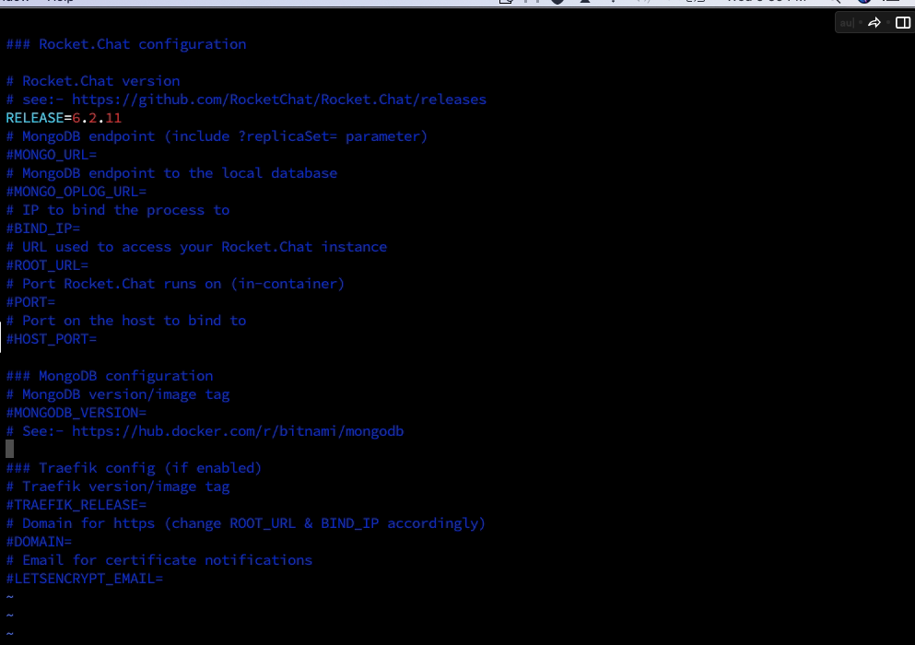

# sudo docker compose up -d
-To start docker

# sudo docker images
-To show the docker images

# sudo docker ps
-To check docker process

# sudo apt install nginx
-To install nginx

# sudo netstat -tulpn | grep -i 80
-To check the port no listening or not

# systemctl status ufw
-To check the firewall status

# sudo systemctl stop ufw
-To stop the firewall service

# systemctl status ufw
--To check the firewall status

# sudo vi /etc/hosts
-Set following parameter accordingly in hosts file.
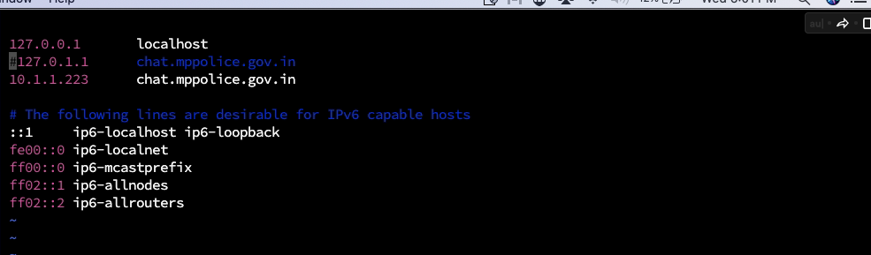

# sudo vi /etc/resolv.conf
-To set parameter accordingly in resolv.conf file
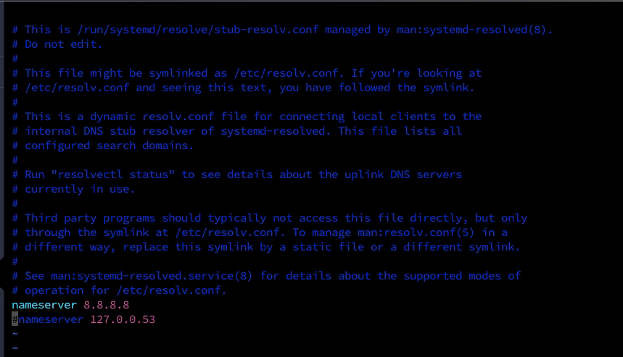

# sudo service docker restart
-To restart the docker service

http://10.1.1.223:3000/
- Use above URL to connect the rocketchat.

