Nagios XI Architecture
Nagios APP1 & APP2 Architecture Document

This document contains the details of Nagios XI instances and their services distribution to other probe servers in Spectra to monitor the Infrastructure at Spectra. APP1 Nagios Server is used to monitor the core infrastructure that contains the devices that are part of Spectra Internal Network. App2 Nagios server monitors the customer CPE devices.

Table of Contents

Nagios XI Architecture…………………………………………………………………………………………………………3
Ram disk and Mysql Database offloading to improve Nagios XI performance…………………………4
Scaling Nagios XI with Mod Gearman Service………………………………………………………………………..4
Hosts/Services Distribution in APP1 Server………………………………………………………………………….5
Hosts/Services Distribution in APP2 Server………………………………………………………………………….8
List of Servers, Core/Other Services and their versions………………………………………………………..11

Nagios XI Architecture

Nagios XI Architecture at Spectra comprises of two instances of Nagios XI server and based on the devices that are being monitored by these two Nagios XI servers, below are the roles of these servers in monitoring the network devices.

Role of APP1 and APP2 Nagios XI Servers:
As part of Spectra Infrastructure monitoring using the Nagios XI Server, the entire monitoring infrastructure is divided into two categories as given below:
- Spectra Internal Network : The devices that are part of Spectra internal network such as routers, switches, servers and other network equipment comes under this category. These also include the Spectra infrastructure located at different locations such as Delhi, Mumbai, Gurgaon, Noida, Bangalore and Chennai. These devices are being monitored by APP1 Nagios Server.

- Spectra Customer CPE (Customer Premises Equipment): The devices that are provided to Spectra customers at different locations such as Delhi, Mumbai, Gurgaon, Noida, Bangalore and Chennai come under this category. These devices are being monitored by APP2 Nagios Server.

In order to improve the performance and scalability of these two nagios servers, some of the services are offloaded to other remote servers and Mod-Gearman service has been used to distribute the host/service checks to other remote worker servers to further reduce the load on Nagios XI Physical Hardware. Apart from these performance measures a fault tolerance mechanism has also been added at mysql database layer using MYSQL database cluster to avoid single point of Database server failure.

Ram disk and Mysql Database offloading to improve Nagios XI performance

The default nagios will handle most of the host/server checks based on the Physical Hardware Capacity. To further enhance this performance two things have been performed without distributing the Hosts/Service checks load to other Probe Servers.
- Using Ram disk
- Offloading the database to a separate server. Further the database is configured in cluster mode to overcome the database server failures by using Active-Passive cluster where the data synchronization happens continuously and the passive server will be activated only when the Primary goes offline due to hardware/Operating System failure.

Scaling Nagios XI with Mod Gearman Service:

Each Nagios instance has two Servers Probe Server-1 and Probe Server-2 that share the load of Hosts/Service checks from the main Nagios XI server by performing the service checks on the monitoring devices and then share the results to Nagios XI for further processing and reporting in Nagios Web Interface.
The Mod-Gearman service runs in server mode in Nagios XI server and it runs in worker mode on Probe Servers. It listens on TCP Port 4730 on Nagios XI server and worker/probe servers connect to this port and take the Hosts/Service checks based on the settings in the mod-gearman configuration files.

Hosts/Services Distribution in APP1 Server

Diagram 1: APP1 Nagios Server instance and the distribution of Host/Service checks to Probe Servers using mod-gearman service.

The distribution of Hosts/Service checks happens via Host Groups/Service Groups in Nagios XI server. This means when a new host is added to Nagios server along with its services configuration, it needs to be added to any one of the existing Host Groups in Nagios XI server based on requirement.
As given in above Diagram 1 note that
- Monitored devices 1, 2 and 3 are the representation of the monitored devices that can belong to any hostgroups as given in Probe server1 Hostgroups list in the diagram.
- Monitored devices 4, 5 and 6 are the representation of the monitored devices that can belong to any hostgroups as given in Probe server 2 Hostgroups list in the diagram.
- Device 7 is an example monitored device that is not part of any defined host groups used for distribution. So it is processed directly by the APP1 Nagios server.

Distributions of Hosts/Service checks in APP1 is taken care by mod-gearman service as per the below configurations in respective Servers.

APP1-NAGIOS XI-SERVER[203.122.61.108]:
hostgroups=Mumbai,Banglore,Noida,Delhi_Zone_2,Delhi_Zone_1,Chennai,Gurgaon,IDC,UPS,UnifyServers
localservicegroups=Bandwidth
PROBE- SERVER-1[203.122.61.121]:
hostgroups=Noida,IDC,UPS,Delhi_Zone_1,Delhi_Zone_2,Gurgaon,UnifyServers
PROBE- SERVER-2[180.151.59.134]:
hostgroups=Banglore,Chennai,Mumbai,Pune

Based on the above mod-gearman configuration on respective servers, GEARMAND-SERVER on Nagios XI picks up the list of host/service checks to be processed based by mod-gearman service and puts them in respective queues and then they are handed over to worker servers based on the host groups list that is configured in their respective worker configuration files.

Below is the order in which the host groups and service groups are processed by the Nagios XI server while distributing the host/service checks to respective worker/probe servers.
NOTE : Anything that is part of Local Service Group or Local Host Group is bypassed by worker servers and is handled by Nagios XI server itself.

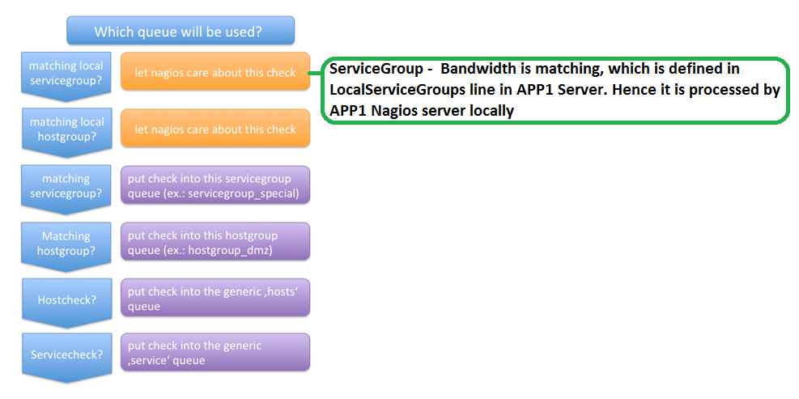

PROBE-SERVER-1[203.122.61.121] : This probe/worker server takes care of plugin checks for all hosts that are part of below host groups from APP1 Nagios XI server and returns check results to APP1 Nagios XI server for further processing and analysis.
HOSTGROUPS: Noida, IDC, UPS, Delhi_Zone_1, Delhi_Zone_2, Gurgaon, UnifyServers
localservicegroups=Bandwidth As the service group “Bandwidth” is defined as a localservicegroup, The APP1 Nagios XI server itself takes care of the plugin checks for all the host services that are members of this service group even though the host belongs to any one of the above listed host groups as this takes precedence over other queues.
NOTE: whenever we add Bandwidth Port for any host in APP 1 server, we need to make sure that the bandwidth Port service is added to this “Bandwidth” service group to avoid the plugin processing by Probe servers as part of standard HostGroups defined above, otherwise you will get rrd file not found warnings in service output in Nagios Dashboard for Bandwidth services.

PROBE-SERVER-2[180.151.59.134] :This probe/worker server takes care of plugin checks for all hosts that are part of below host groups from APP1 nagios XI server and returns check results to APP1 Nagios XI server for further processing and analysis.
HOSTGROUPS : Mumbai, Banglore, Chennai

Hosts/Services Distribution in APP2 Server

Distributions of Hosts/Service checks in APP2 is taken care by mod-gearman service as per the below mod-gearman configurations in respective Servers.
Diagram 2: APP2 Nagios Server instance and the distribution of Host/Service checks to Probe Servers using mod-gearman service.

APP2 [203.122.61.114]:
hostgroups=Mumbai_CPE,Banglore_CPE,Chennai_CPE,Delhi_CPE,Gurgaon_CPE,Noida_CPE
PROBE- SERVER-1[203.122.61.124]:
hostgroups=Delhi_CPE,Gurgaon_CPE,Noida_CPE
PROBE- SERVER-2[203.92.38.134]:
hostgroups=Mumbai_CPE,Banglore_CPE,Chennai_CPE

As given in above Diagram 2 note that
- Monitored devices 1, 2 and 3 are the representation of the monitored devices that can belong to any hostgroups as given in Probe server1 Hostgroups list in the diagram.
- Monitored devices 4, 5 and 6 are the representation of the monitored devices that can belong to any hostgroups as given in Probe server 2 Hostgroups list in the diagram.
- Device 7 is an example monitored device that is not part of any defined host groups used for distribution. So it is processed directly by the APP2 Nagios server.

PROBE-SERVER-1[203.122.61.124] : This probe/worker server takes care of plugin checks for all hosts that are part of below host groups from APP2 Nagios XI server and returns check results to APP 2 Nagios XI server for further processing and analysis.
HOSTGROUPS: Delhi_CPE, Gurgaon_CPE, Noida_CPE

PROBE-SERVER-2 [203.92.38.134] : This probe/worker server takes care of plugin checks for all hosts that are part of below host groups from APP2 Nagios XI server and returns check results to APP 2 Nagios XI server for further processing and analysis.
HOSTGROUPS : Mumbai_CPE, Banglore_CPE, Chennai_CPE

List of Servers, Core/Other Services and their versions

S.NO | Server Name | IP Address | Role | OS | Core Services | Other Services
1 | APPSERVER1 | 203.122.61.108 | NAGIOS XI SERVER | CentOS release 6.9 | Nagiosxi-5.5.7,mod-gearmand-0.33
2 | DBSERVER1 | 180.151.100.82 | PRIMARY DB SERVER | CentOS release 6.8 | Mysql-5.1.73-7
3 | DBSERVER1HA | 180.151.100.83 | SECONDARY DB SERVER | CentOS release 6.8 | Mysql-5.1.73-8
4 | NCRPROB2 | 203.122.61.124 | PROBE-SERVER-1 | CentOS release 6.9 | Mod-gearman-worker-2.1.1 | Smokeping-2.4.2
5 | CHENNAIPROB | 180.151.59.134 | PROBE-SERVER-2 | CentOS release 6.9 | Mod-gearman-worker-2.1.1 | Smokeping-2.6.11
6 | APPSERVER2 | 203.122.61.114 | NAGIOS XI SERVER | CentOS release 6.9 | Nagiosxi-5.5.7, mod-gearmand-0.33
7 | DBSERVER2 | 180.151.100.84 | PRIMARY DB SERVER | CentOS release 6.8 | Mysql-5.1.73-7
8 | DBSERVER2HA | 180.151.100.85 | SECONDARY DB SERVER | CentOS release 6.8 | Mysql-5.1.73-8
9 | NAGIOSPROB3HA | 203.122.61.124 | PROBE-SERVER-1 | CentOS release 6.8 | Mod-gearman-worker-2.1.1 | Smokeping-2.6.11
10 | MUMBAIPROB | 203.92.38.134 | PROBE-SERVER-2 | CentOS release 6.9 | Mod-gearman-worker-2.1.1 | Smokeping-2.6.11

