Rocketchat Presentation Documentation

user – 1st Test11
url: https://10.1.1.227/
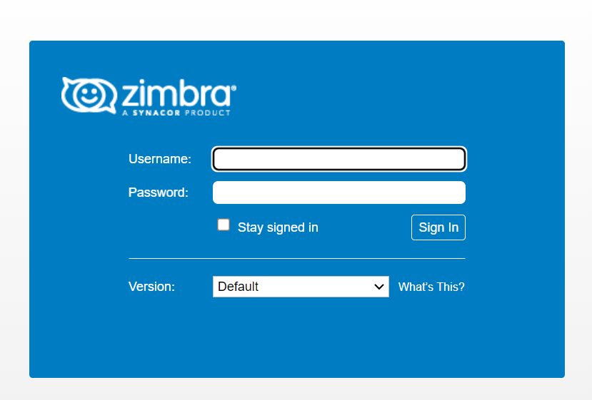
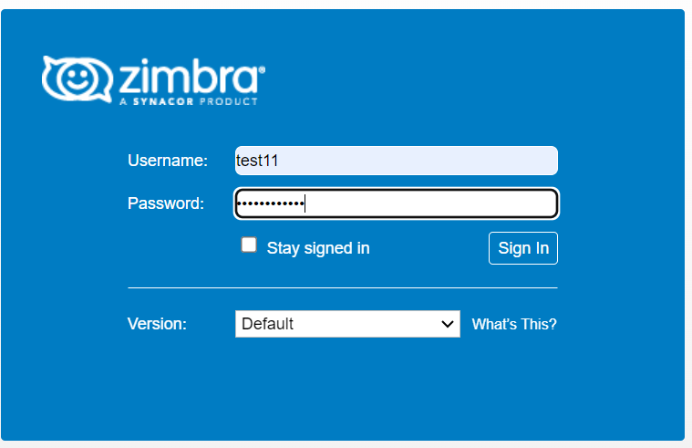

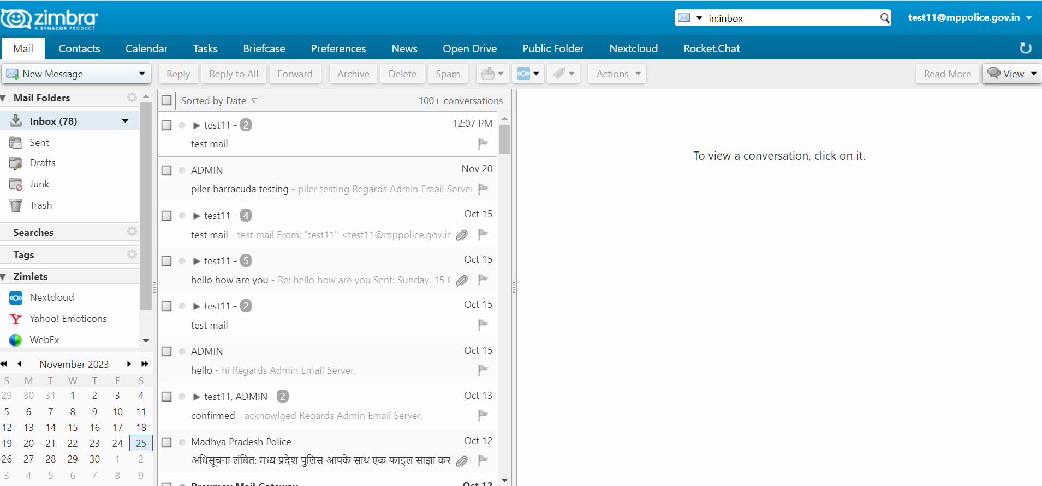

Go to the Rocketchat Option which are mention above click on that It open an interface which are metion below.
Note – we have to login through username/Email and password in rocketchat

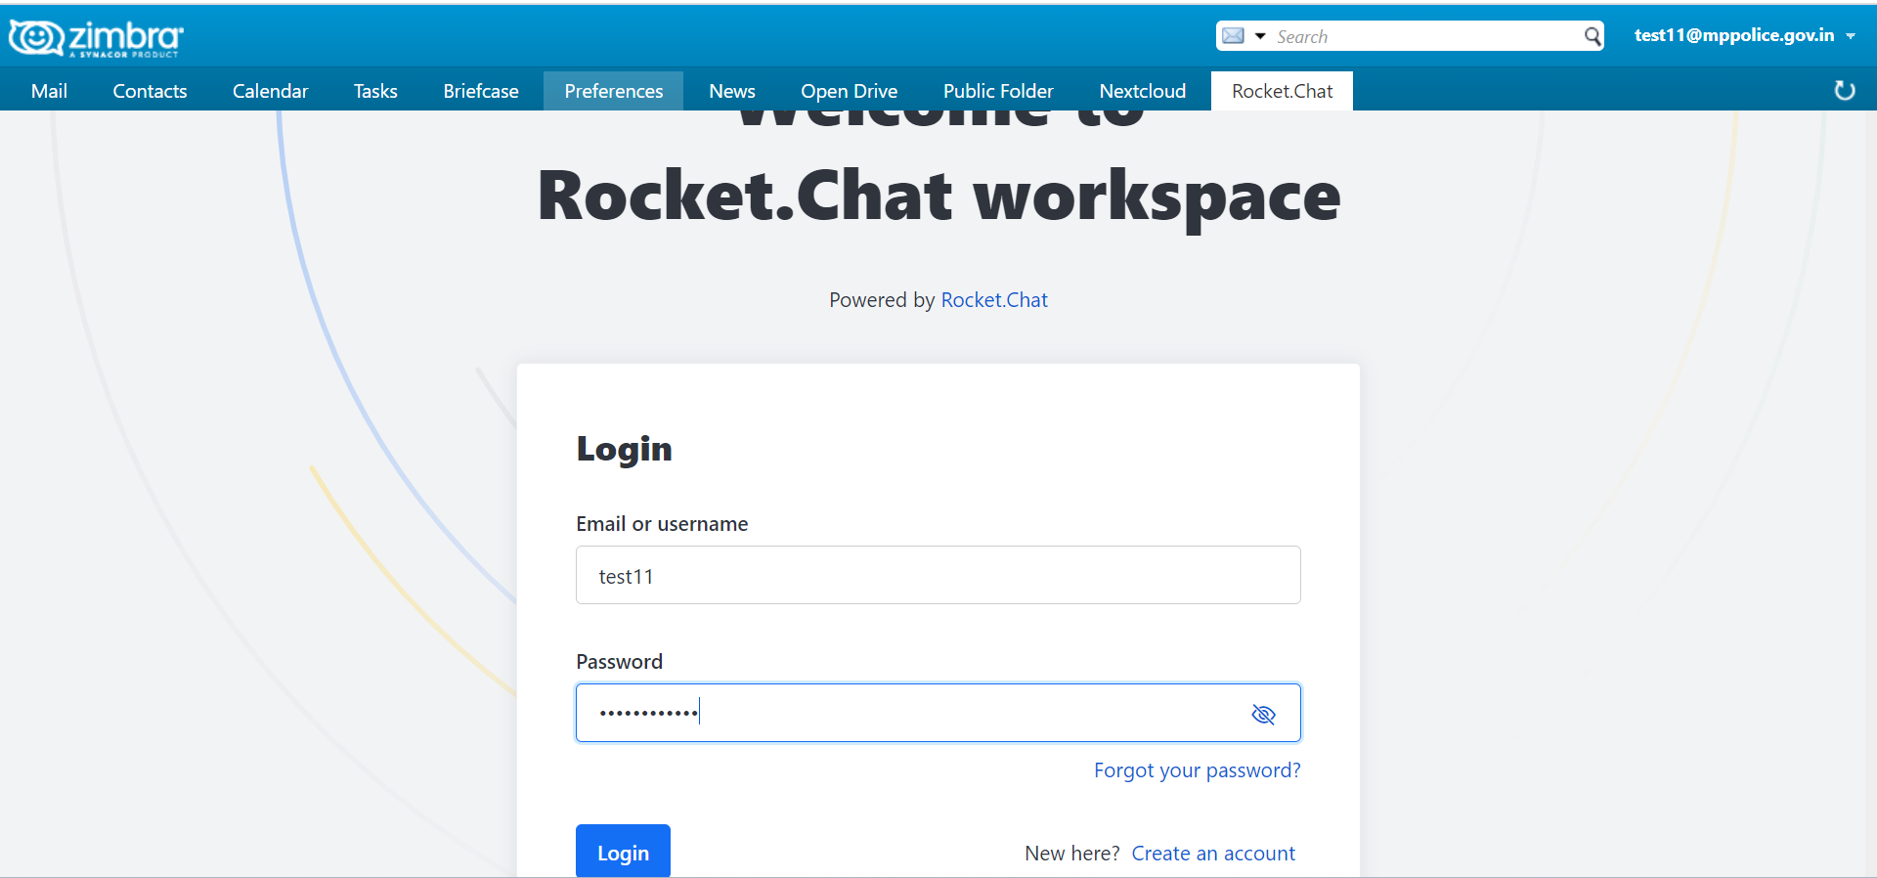

After Successful login , It open an interface which are mention below
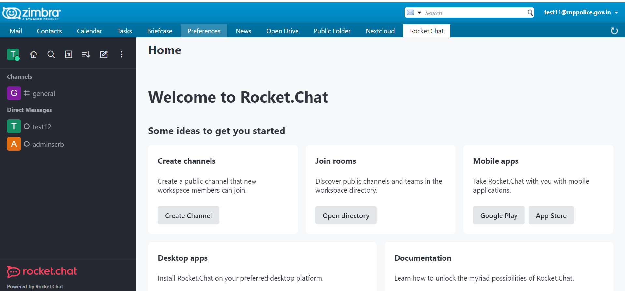

Here we see the user who are login Click on the user which we want to chat
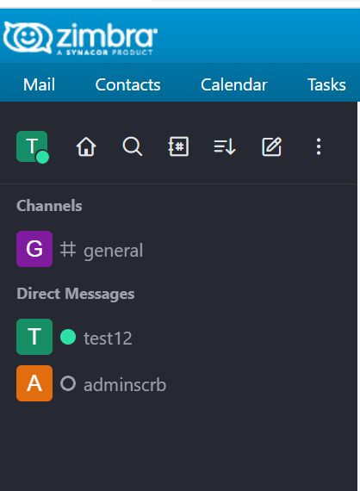

In this case we want to chat test12 user when we click on test12 user it open a cosole which are below

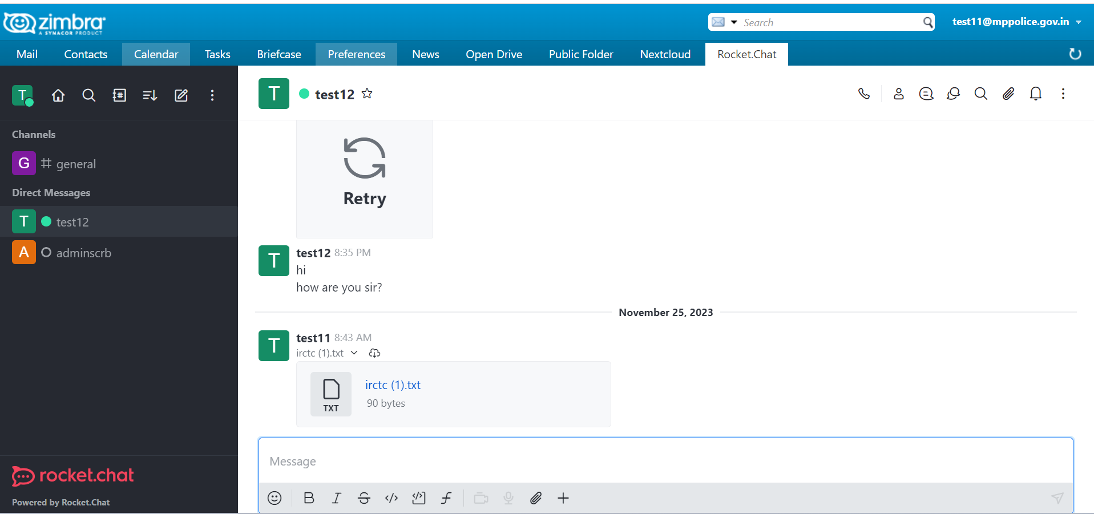

Now, We send a text message to <user12> ‘Hello, test12 how are you’, which are mention below
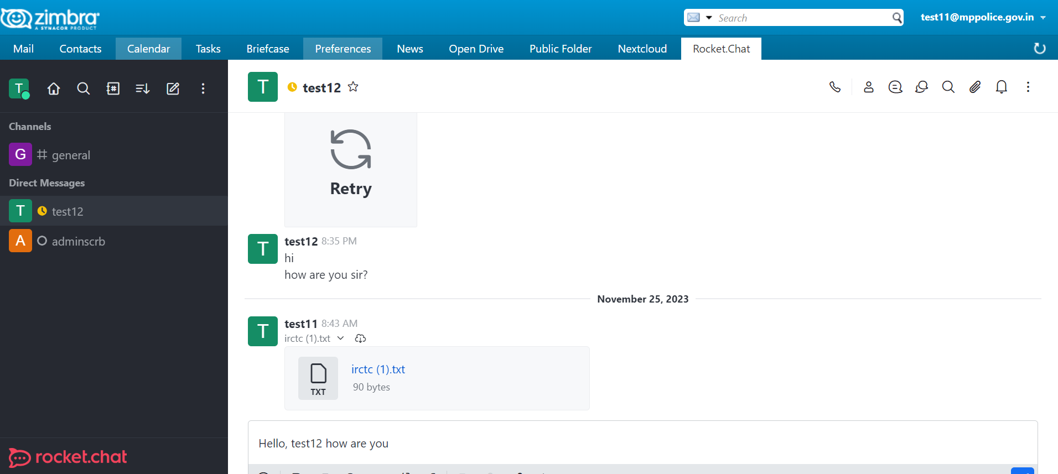

Now, it received on another side <test12> ‘Hello, test12 how are you’ which are mention below
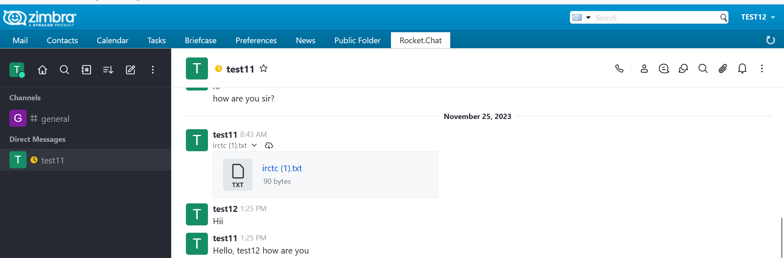

user -2nd Test12
url: https://10.1.1.227/
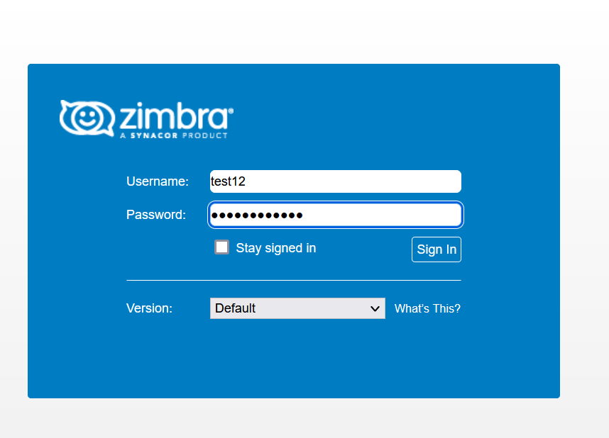
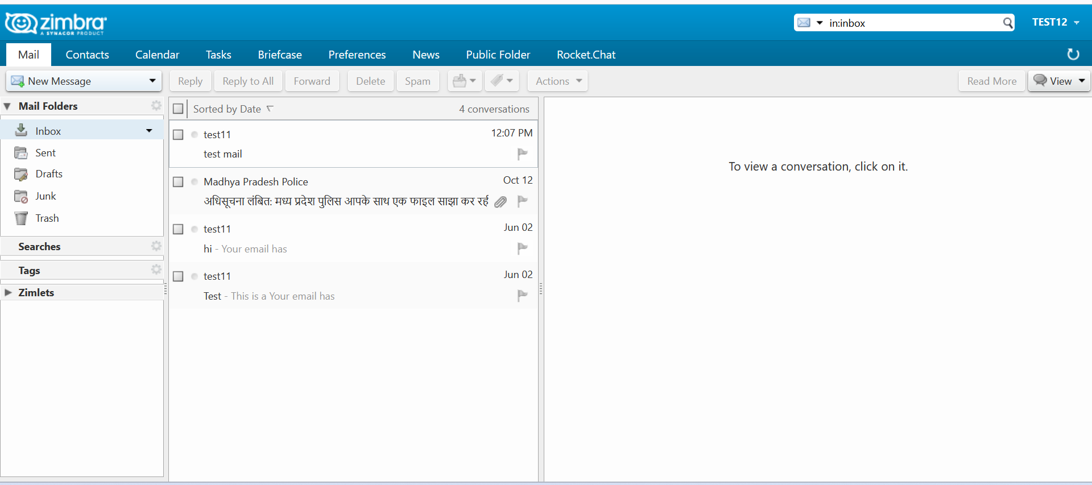

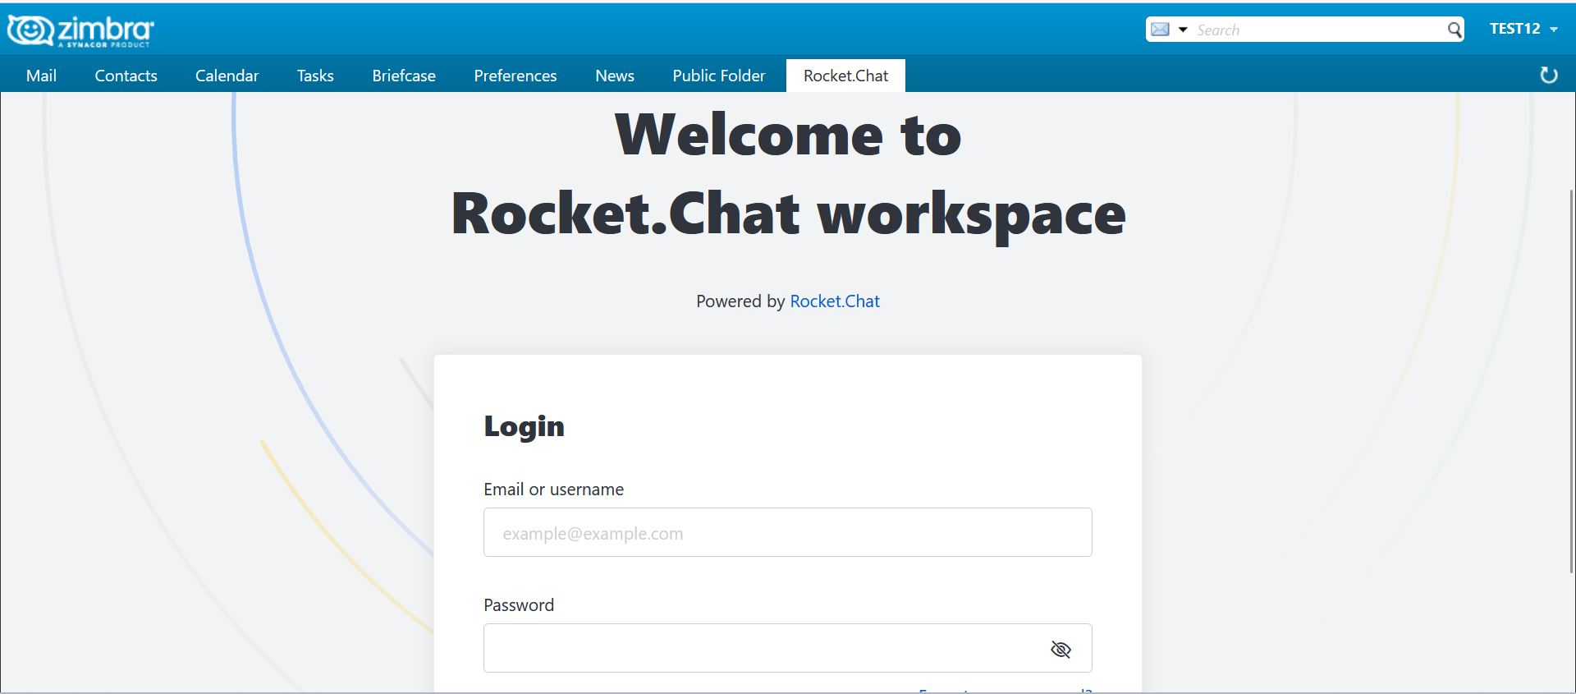

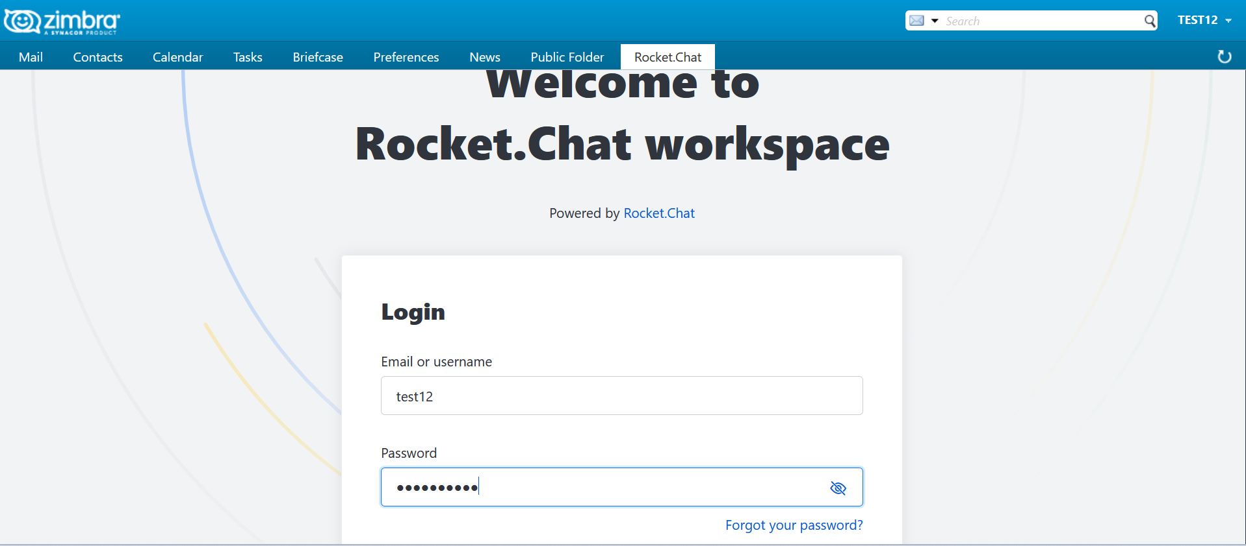

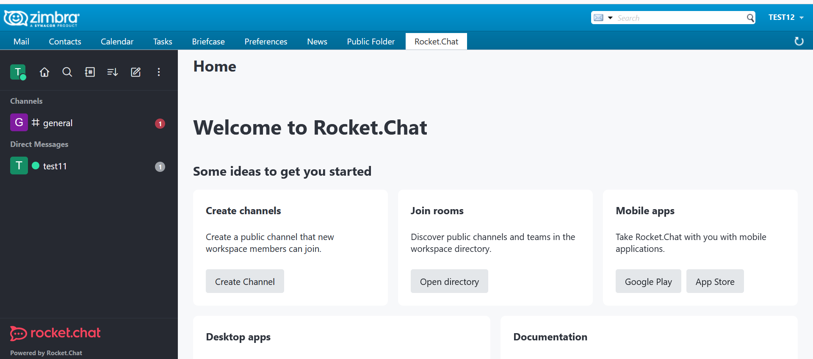

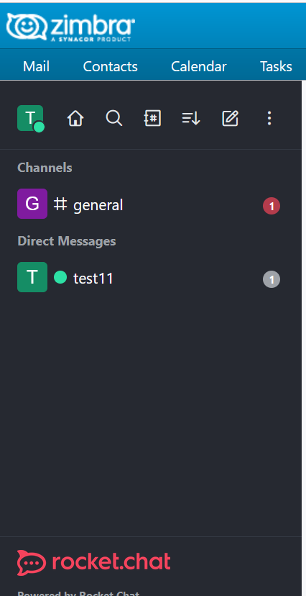
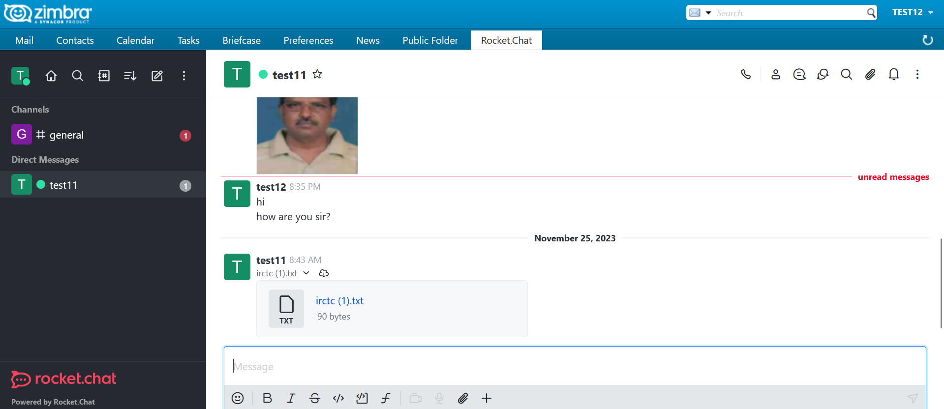

Here we receive the sent mail of <test11> user ‘Hello, test12 how are you’
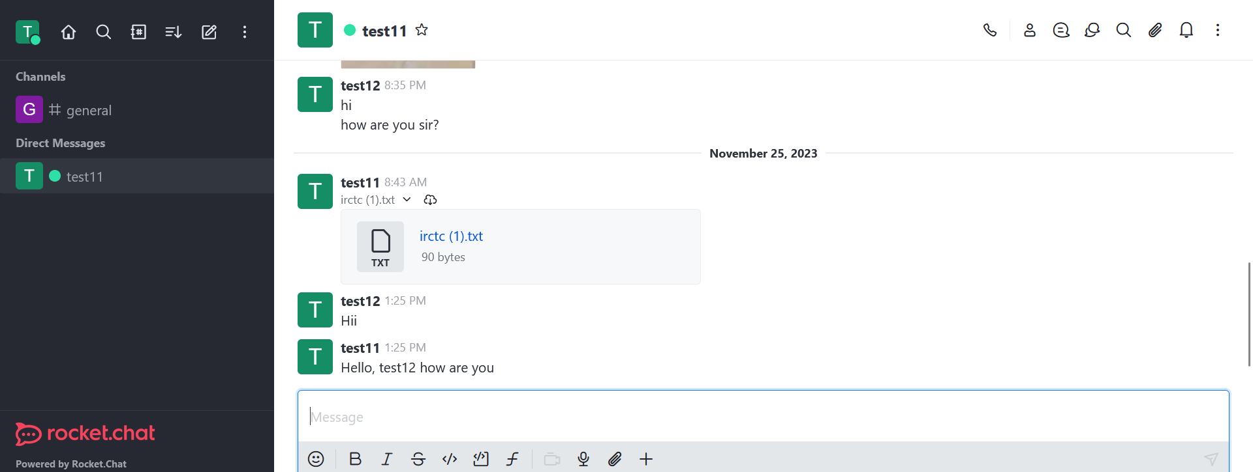

Now, we replied on <test12 user> ‘Hello,test11 I am fine thank you’ which are mention below

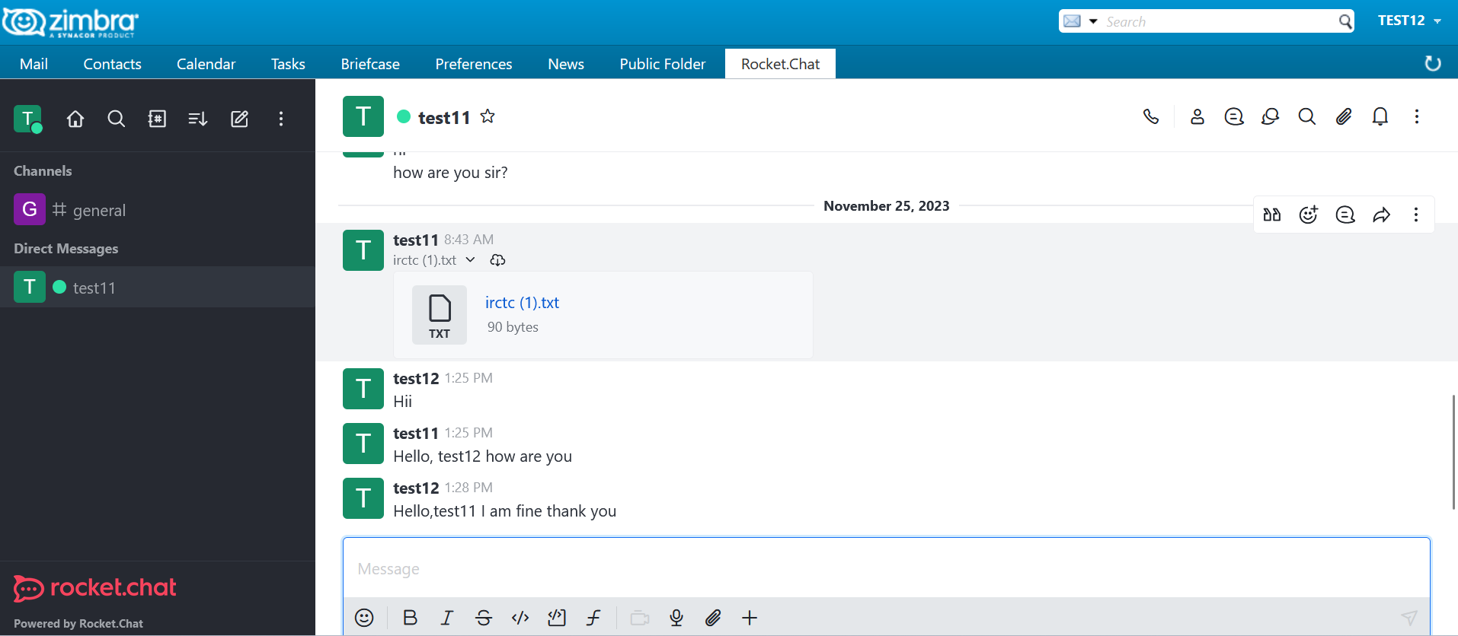

Now It received on test11 user
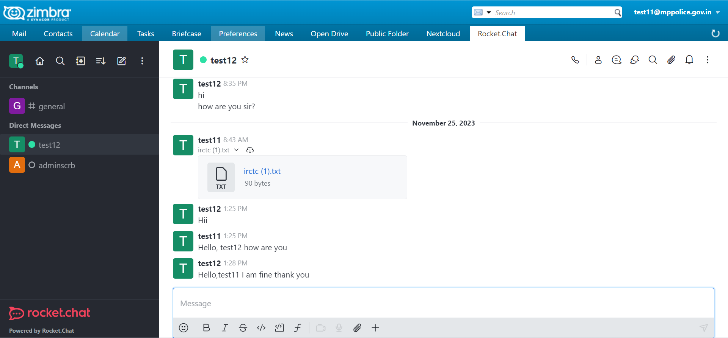

Note – Now It properly work

