Nextcloud Presentation Documentation
url: https://mail.mppolice.gov.in/
user – 1st Test11
- Enter Correct username and Password
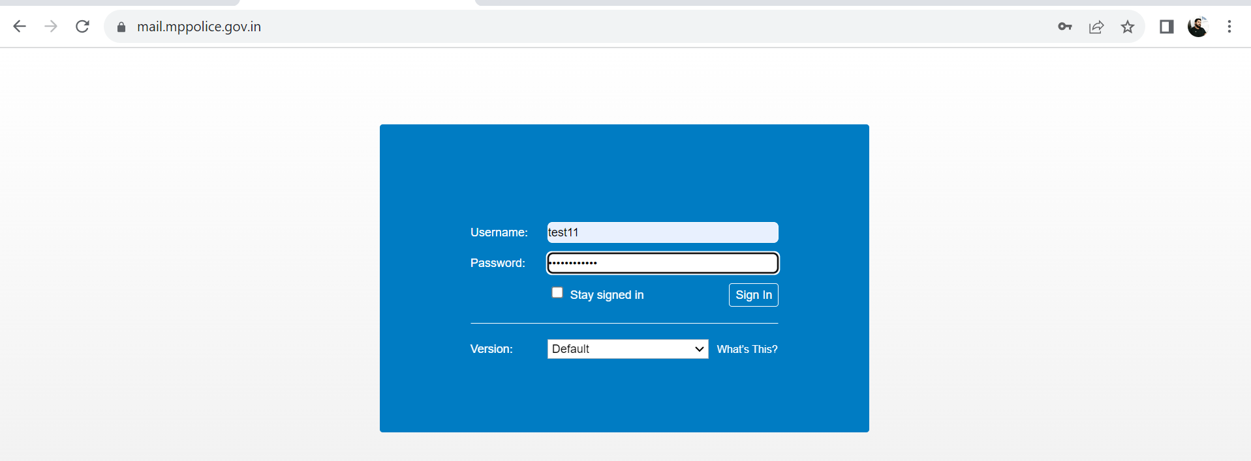

- Login Sucessful
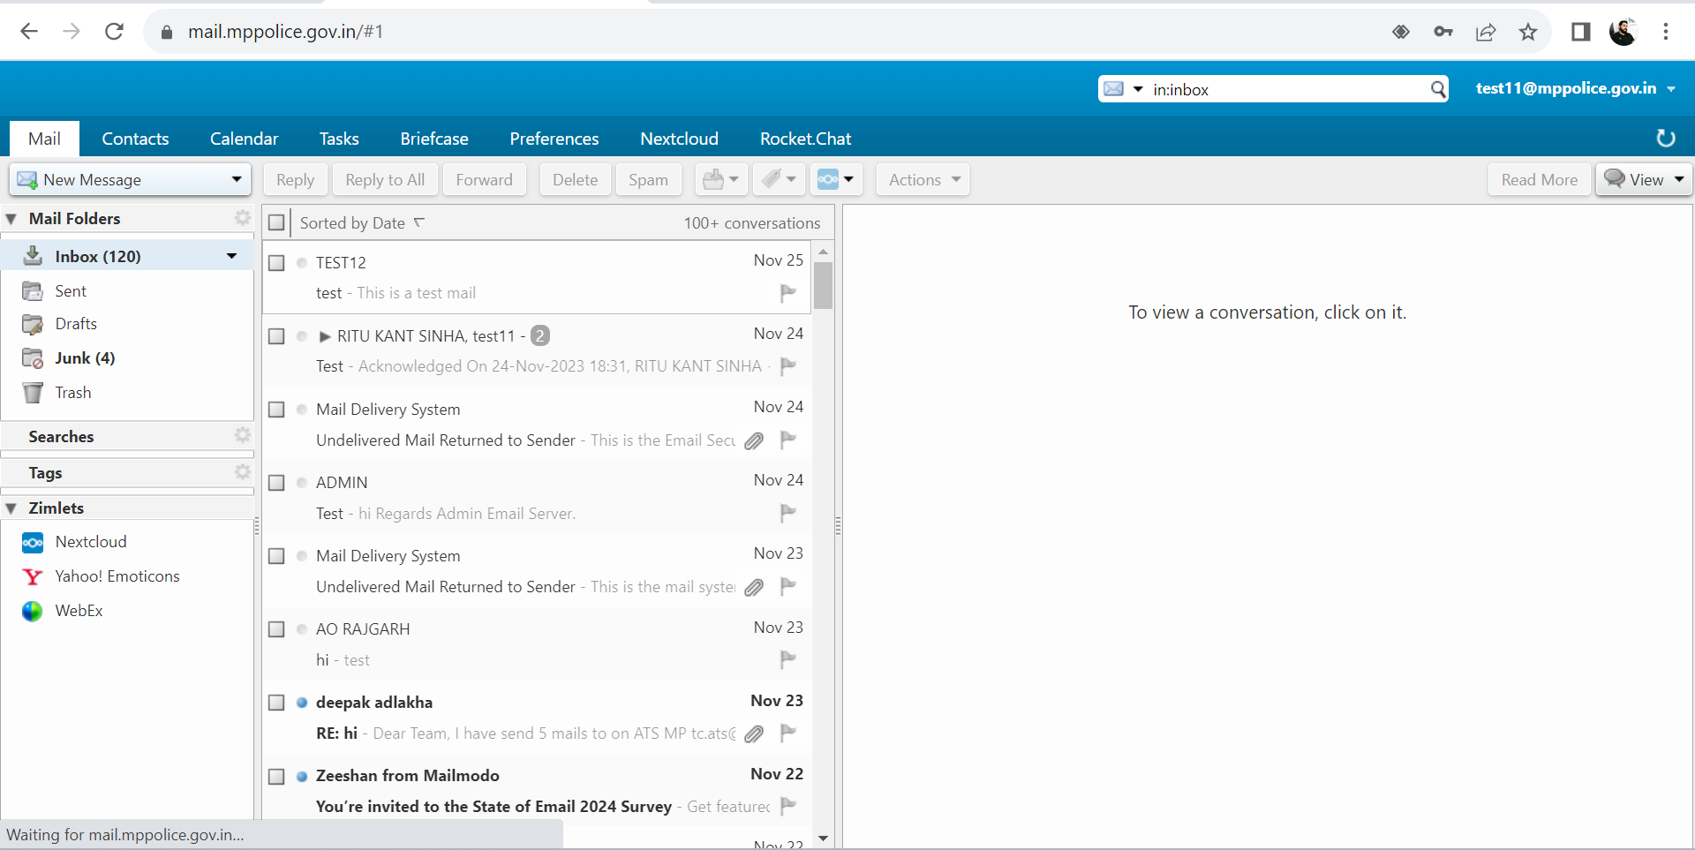

- Go to the tab Nextcloud

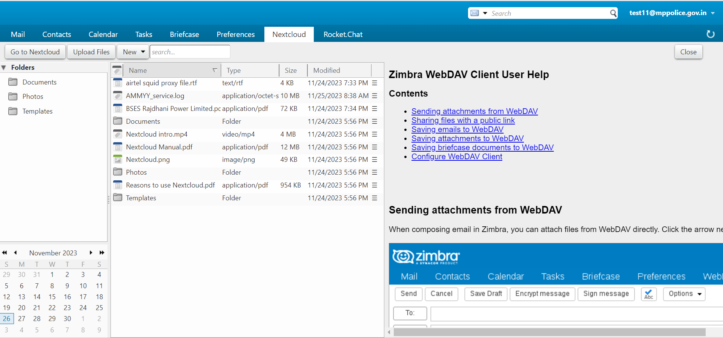

- Go to the option Upload file It open a dialogue box to upload file choose file

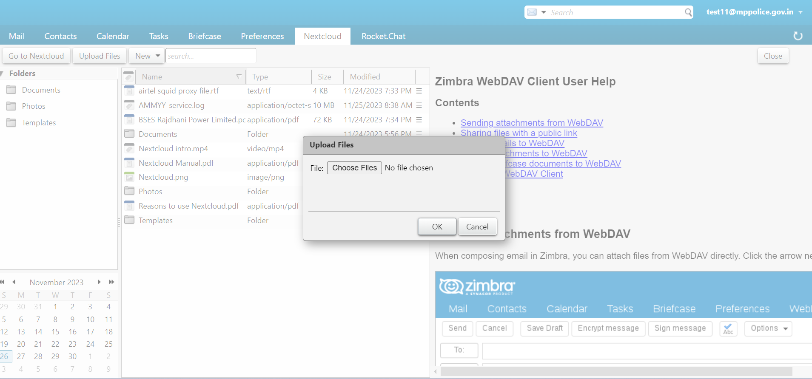

- Choose any file which we want to upload
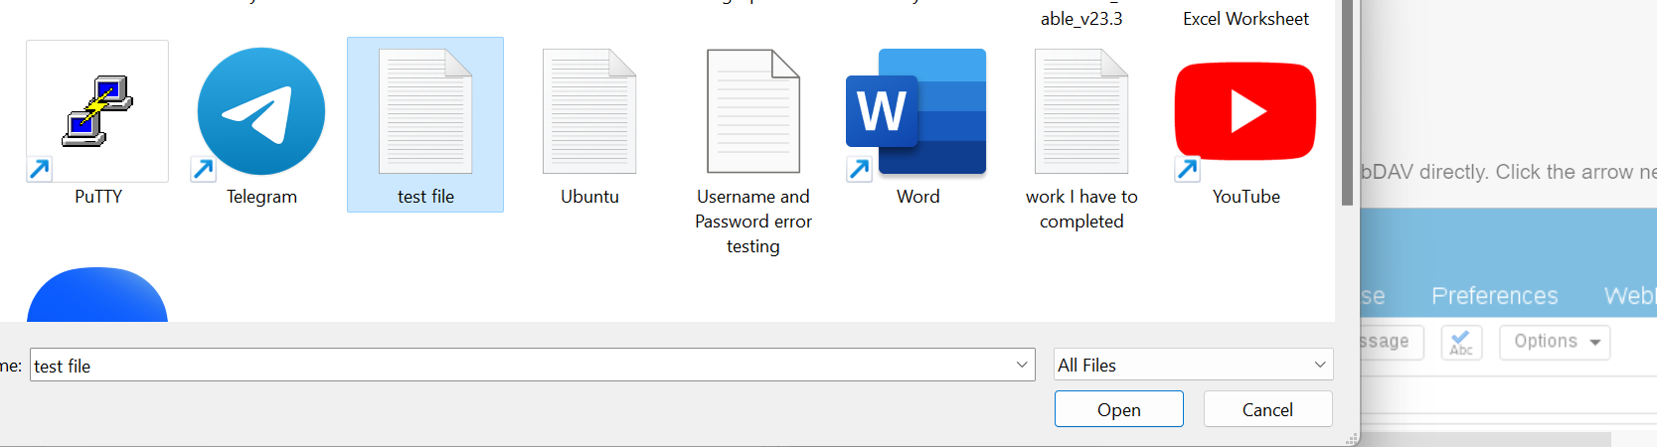

- Now it upload the file named test file which are shown below

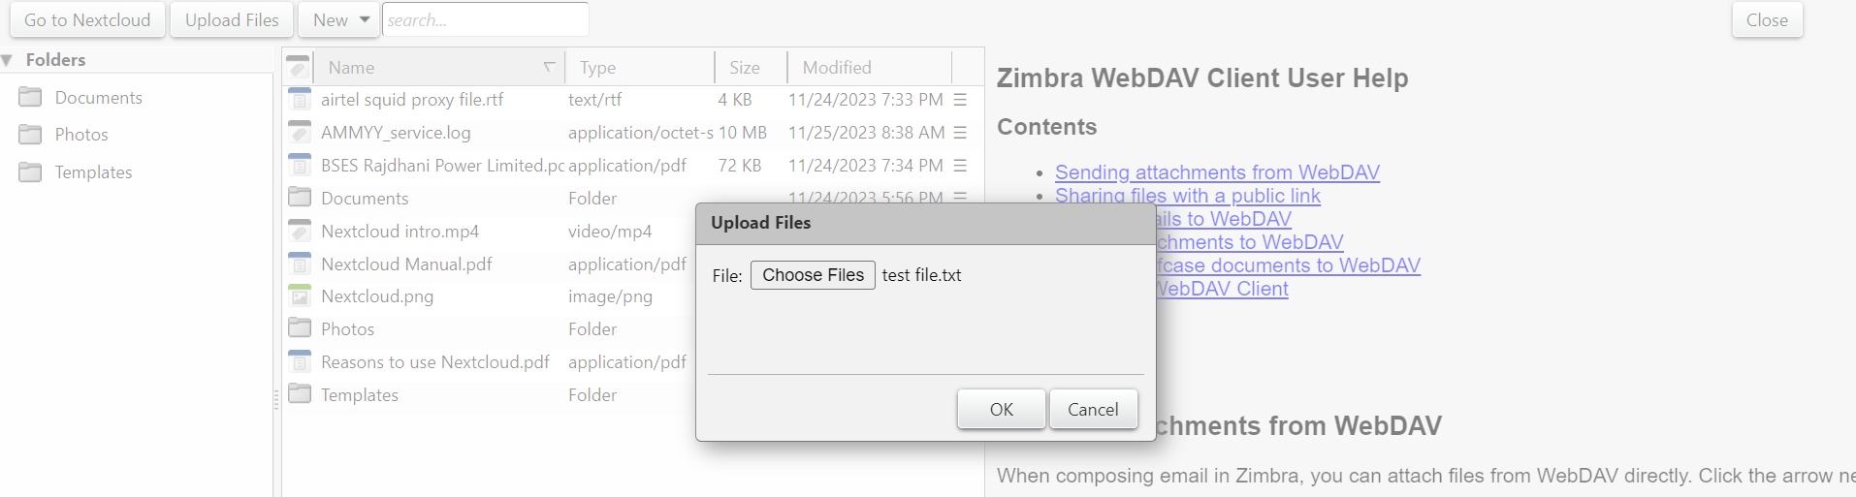
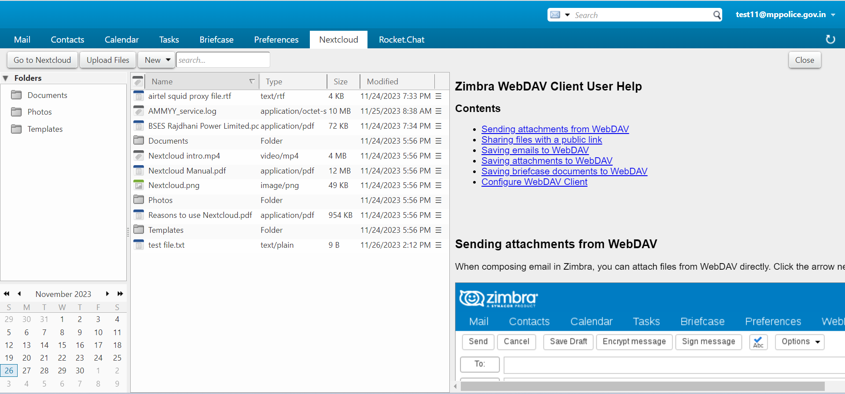

- Go to the option Go to Nextcloud

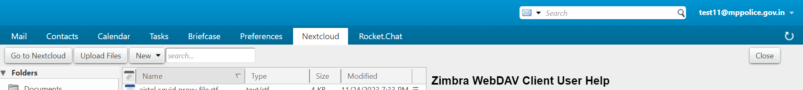

- It open a new page , we can directly enter in Nextcloud by entering Username and Password
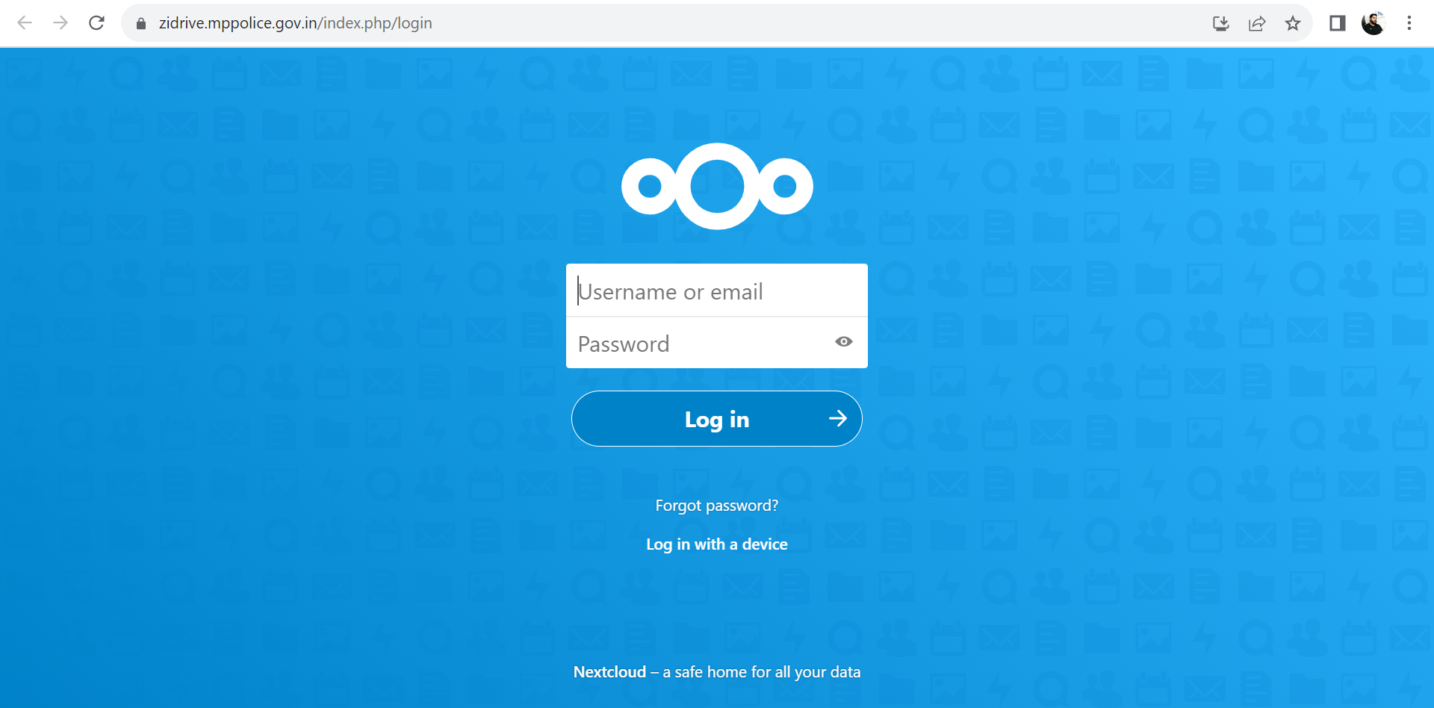

- Go to the option New
- We can create new Document , new spreedsheet..and much more

