Dear Sir,
Snapshot Backup of below running VM's is working

1. NFA Database
2. Partner Portal
3. Alma Linux
4. Sdnet Server
5. Axis-bank

Server IP - 192.168.0.55 [ Beetel Primary Server ]
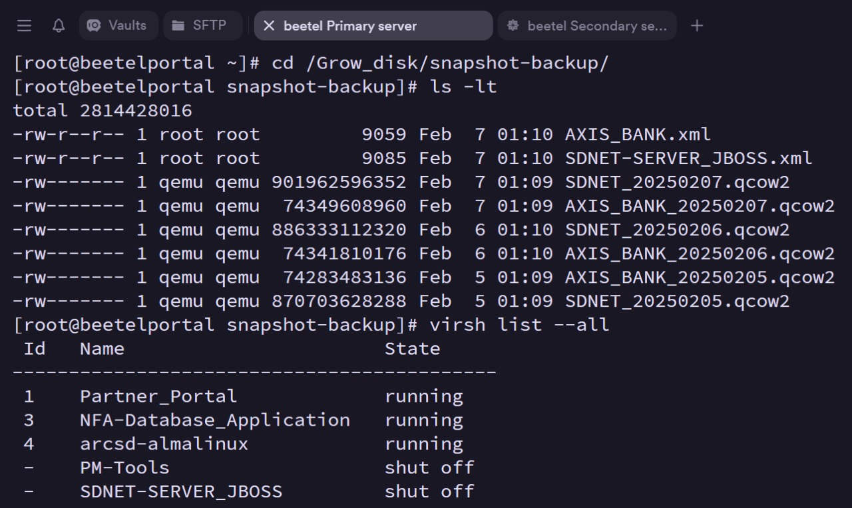

Server IP - 192.168.0.54 [ Beetel Secondary Server ]
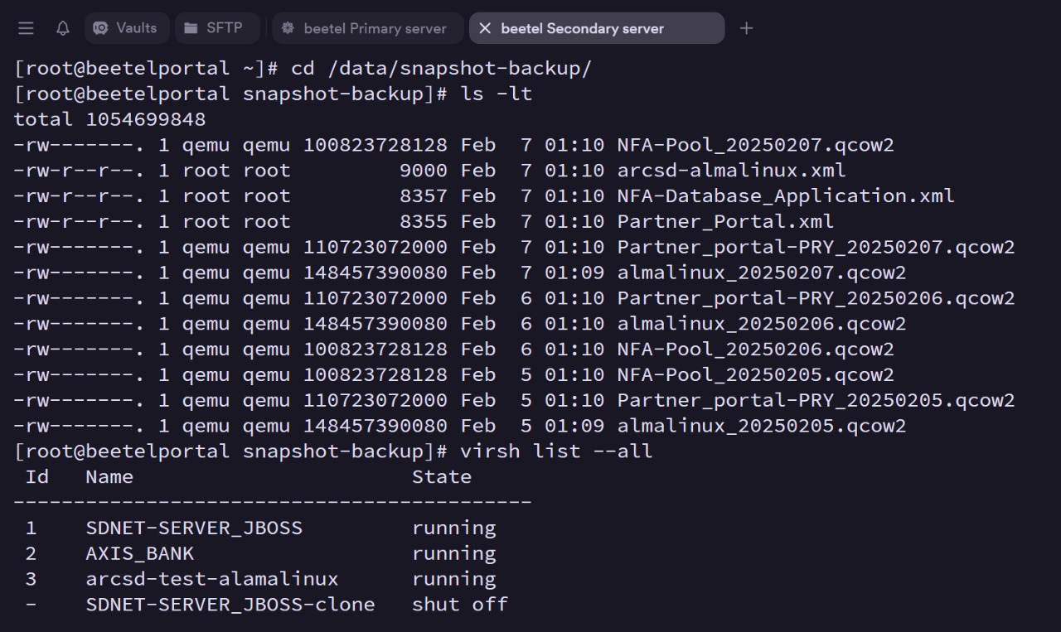

Thanks & Regards
Tushar Sonawane

Note - Check All VM On Primary Server That Are Running As Mentioned In Screenshot
Check All VM On Secondary Server That Are Running As Mentioned In Screenshot
Ensure 3 Latest Days Snapshot Of Running VM On Primary Server Should Be Present On Secondary Server
Ensure 3 Latest Days Snapshot Of Running VM On Secondary Server Should Be Present On Secondary Server
Update These Details On Every Friday At 10:30 AM On The Ticket No 2025020771000027 .

Snapshot Backup of below running VM's is working

1. NFA Database
2. Partner Portal
3. Alma Linux
4. Sdnet Server
5. Axis-bank''
''
Server IP - 192.168.0.55 [ Beetel Primary Server ]''
Check All VM On Primary Server That Are Running As Mentioned Below
1. Sdnet Server
2. Axis-bank
''
cd /Grow_disk/snapshot-backup
ls -lt
virsh list --all''

NOTE:
attach screenshot of above command here
Ensure 3 Latest Days Snapshot Of Running VM On Primary Server Should Be Present On Secondary Server

''
Server IP - 192.168.0.54 [ Beetel Secondary Server ]''

--------------------------------------------------------------------
NOTE
Check All VM On Secondary Server That Are Running As Mentioned Below
1. NFA Database
2. Partner Portal
3. Alma Linux
----------------------------------------------------------------------
''cd /data/snapshot-backup
ls -lt
virsh list --all''
-------------------------------------------------------------------------
NOTE:
attach screenshot of above command here
Ensure 3 Latest Days Snapshot Of Running VM On Secondary Server Should Be Present On Secondary Server
------------------------------------------------------------------------------------------------------

'''Use ticket for your reference - Ticket#2025020771000027 — RE: Beetel Backup & snapshot required'''

