Project Name - MP Police
Integration of Active Sync Server with Zimbra
Last Updated : 27th November 2023
Prepared By
Tetra Information Services Pvt. Ltd, Team

CAUTION
This document is released by Tetra Information Services Pvt. Ltd
The information contained in this document is confidential and no part of this document may be reproduced, stored in a retrieval system or transmitted in any form or by any means, electronic, mechanical, photocopying, recording or otherwise, without the prior written consent.

Document Control
Document No | Tetra_Doc3
Version No | 6.2.11
Prepared By | Tetra Information Services Pvt. Ltd
Release Date | 27th November 2023

Revision Control Information
File Name :Integration of Active sync Server with Zimbra.pdf

S.No | Section No | Nature of Amendment | Document Version No | Document Release Date | Remarks
1 | All | Initial | 6.2.11 | 3rd November 2023 | Integration of Active sync Server with Zimbra

Table of Contents
1 Integration of Active sync server with Zimbra
1.1
1.2
2 Dos and Donts of rocket chat server
3 FAQ
3.1 Instalation
3.1.1 Heading2.1.1

Integration of Active sync server with zimbra

# yum update -y
-To update yum repository
# sestatus
-To show selinux status
# setenforce 0
# vi /etc/sysconfig/selinux
-To disable selinux
# systemctl status firewalld
-To check firewall status
# systemctl stop firewalld
-To stop firewall service
# systemctl disable firewalld
-To disable firewall service
# yum install php-cli php-soap php-process php httpd
# yum install httpd php php-imap php-soap php-json php-mbstring php-mcrypt php-xml php-cli php-ldap wget unzip
# wget -c https://download.z-push.org/final/2.3/z-push-2.3.9.tar.gz
# tar -zxvf z-push-2.3.9.tar.gz
# mv z-push-2.3.9 /var/www/html/z-push
# mkdir /var/lib/z-push /var/log/z-push
-Make a directory z-push in above path
# chmod 755 /var/lib/z-push /var/log/z-push
-Change permission of z-push file
# chown apache:apache /var/lib/z-push /var/log/z-push
-Change ownership of z-push file
# vi /etc/httpd/conf.d/z-push.conf
-Make a z-push.conf file and set below parameter
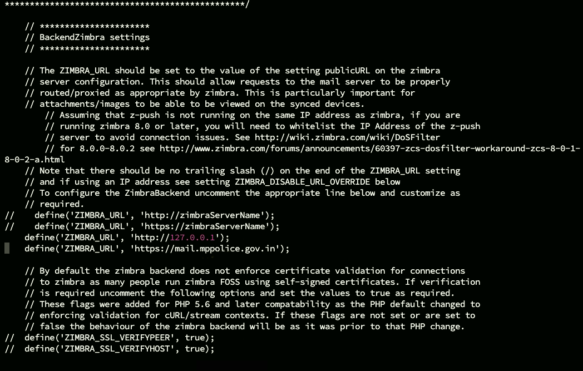
# vi /etc/php.ini
-It create a file named php.ini and set below limit
Also make sure memory_limit = 128M on /etc/php.ini. Download Z-Push Zimbra Backend
# wget -c http://downloads.sourceforge.net/project/zimbrabackend/Release61/zimbra61.tgz
-It download above tar file
# tar -zxvf zimbra61.tgz
-It extract the tar file
# mv zimbra61/z-push-2/ /var/www/html/z-push/backend/zimbra
Configure Z-Push for using Zimbra Backend
# vi /var/www/html/z-push/config.php
change and adjust with your region
define('PROVISIONING', false);
define('LOOSE_PROVISIONING', true);
define('TIMEZONE', 'Asia/Kolkata');
define('BACKEND_PROVIDER', 'BackendZimbra');
Configure Zimbra Backend and define Zimbra URL to localhost or hostname of Zimbra
# vi /var/www/html/z-push/backend/zimbra/config.php
-It create a config.php file and Set below parameter in config.php file

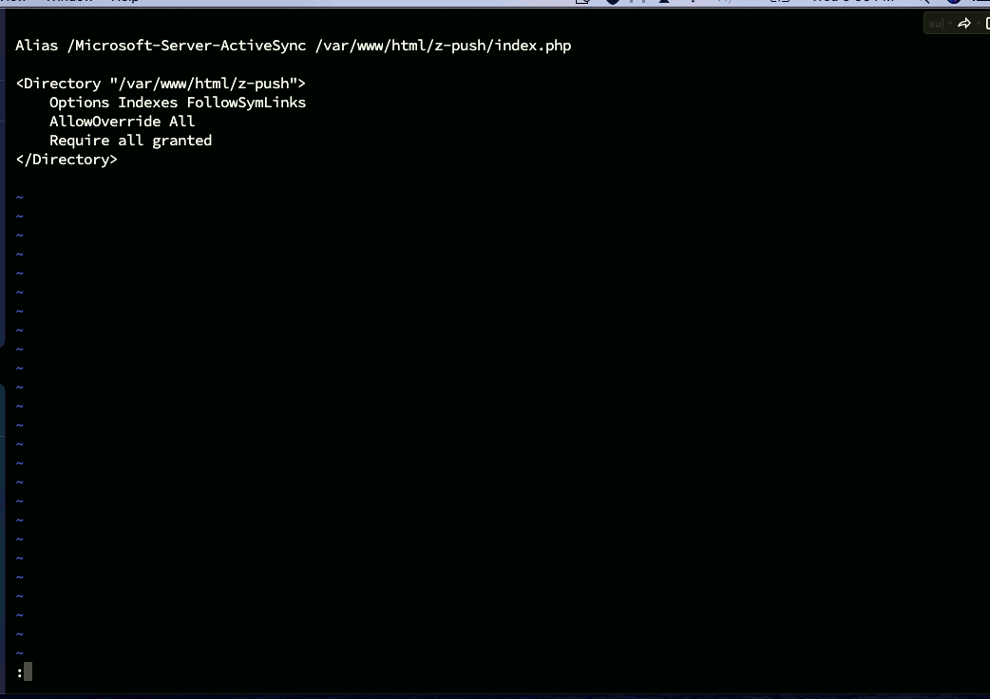

Changes on Zimbra Server
If running Zimbra 8 onwards you need to whitelist your Z-Push server otherwise its likely to get blocked by Zimbra, on your Zimbra server allow your Z-Push server's IP address
# zmprov mcf zimbraHttpThrottleSafeIPs 10.1.1.222
# cd /var/www/html/z-push
# vi .htaccess
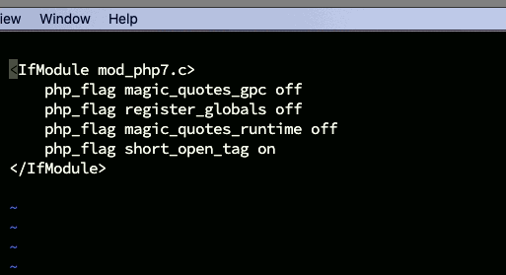
url- http://10.1.1.222/Microsoft-Server-ActiveSync

