Project Name - MP Police
Installation Of Nextcloud server
Last Updated : 27th November 2023
Prepared By
Tetra Information Services Pvt. Ltd, Team

CAUTION
This document is released by Tetra Information Services Pvt. Ltd
The information contained in this document is confidential and no part of this document may be reproduced, stored in a retrieval system or transmitted in any form or by any means, electronic, mechanical, photocopying, recording or otherwise, without the prior written consent.

Document Control
Document No | Tetra_Doc3
Version No | 1.4
Prepared By | Tetra Information Services Pvt. Ltd
Release Date | 27th November 2023

Revision Control Information
File Name : Rocketchat Server Installation .pdf

S.No | Section No | Nature of Amendment | Document Version No | Document Release Date | Remarks
1 | All | Initial | 1.4 | 3rd November 2023 | Nextcloud Installation

Table of Contents
1 Installation of Nextcloud server
1.1
1.2
2 Dos and Donts of Nextcloud server
3 FAQ
3.1 Instalation
3.1.1 Heading2.1.1

Installation of Nextcloud Server

- Server address: 10.1.1.226
- Hostname: cloud-storage.gov.in
- Os: ubuntu 20.04 LTS

1. Install Packages
1. Update and Upgrade the Ubuntu Packages
# apt update && apt upgrade

2. install Apache and MySQL Server
# apt install apache2 mariadb-server

3. Install PHP and other Dependencies and Restart Apache
# apt-get install php7.4
# apt install libapache2-mod-php php-bz2 php-gd php-mysql php-curl php-mbstring php-imagick php-zip php-ctype php-curl php-dom php-json php-posix php-bcmath php-xml php-intl php-gmp zip unzip wget

4. Enable required Apache modules and restart Apache:
# a2enmod rewrite dir mime env headers
# systemctl restart apache2

2. Configure MySQL Server
1. Login to MySQL Prompt, Just type
# mysql -u root -p
Password: root

2. Create MySQL Database and User for Nextcloud and Provide Permissions.

# CREATE USER 'nextcloud'@'localhost' IDENTIFIED BY 'cloud@$123';

CREATE DATABASE IF NOT EXISTS nextcloud CHARACTER SET utf8mb4 COLLATE utf8mb4_general_ci;
# GRANT ALL PRIVILEGES ON nextcloud.* TO 'nextcloud'@'localhost';
# FLUSH PRIVILEGES;
quit;
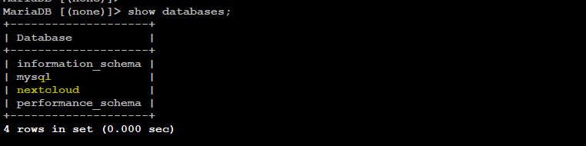
NOTE– DATABASE NAME: nextcloud
USERNAME: nextcloud
PASSWORD : cloud@$123

3. Download and Install Nextcloud
1. Download and unzip at the web root (/var/www/html) folder
# cd /var/www/html
# wget https://download.nextcloud.com/server/releases/nextcloud-23.0.12.zip

2. Change the ownership of the nextcloud content directory to the HTTP user.
# chown -R www-data:www-data /var/www/nextcloud

3. Define the config for nextcloud in apache
# vi /etc/apache2/sites-available/nextcloud.conf
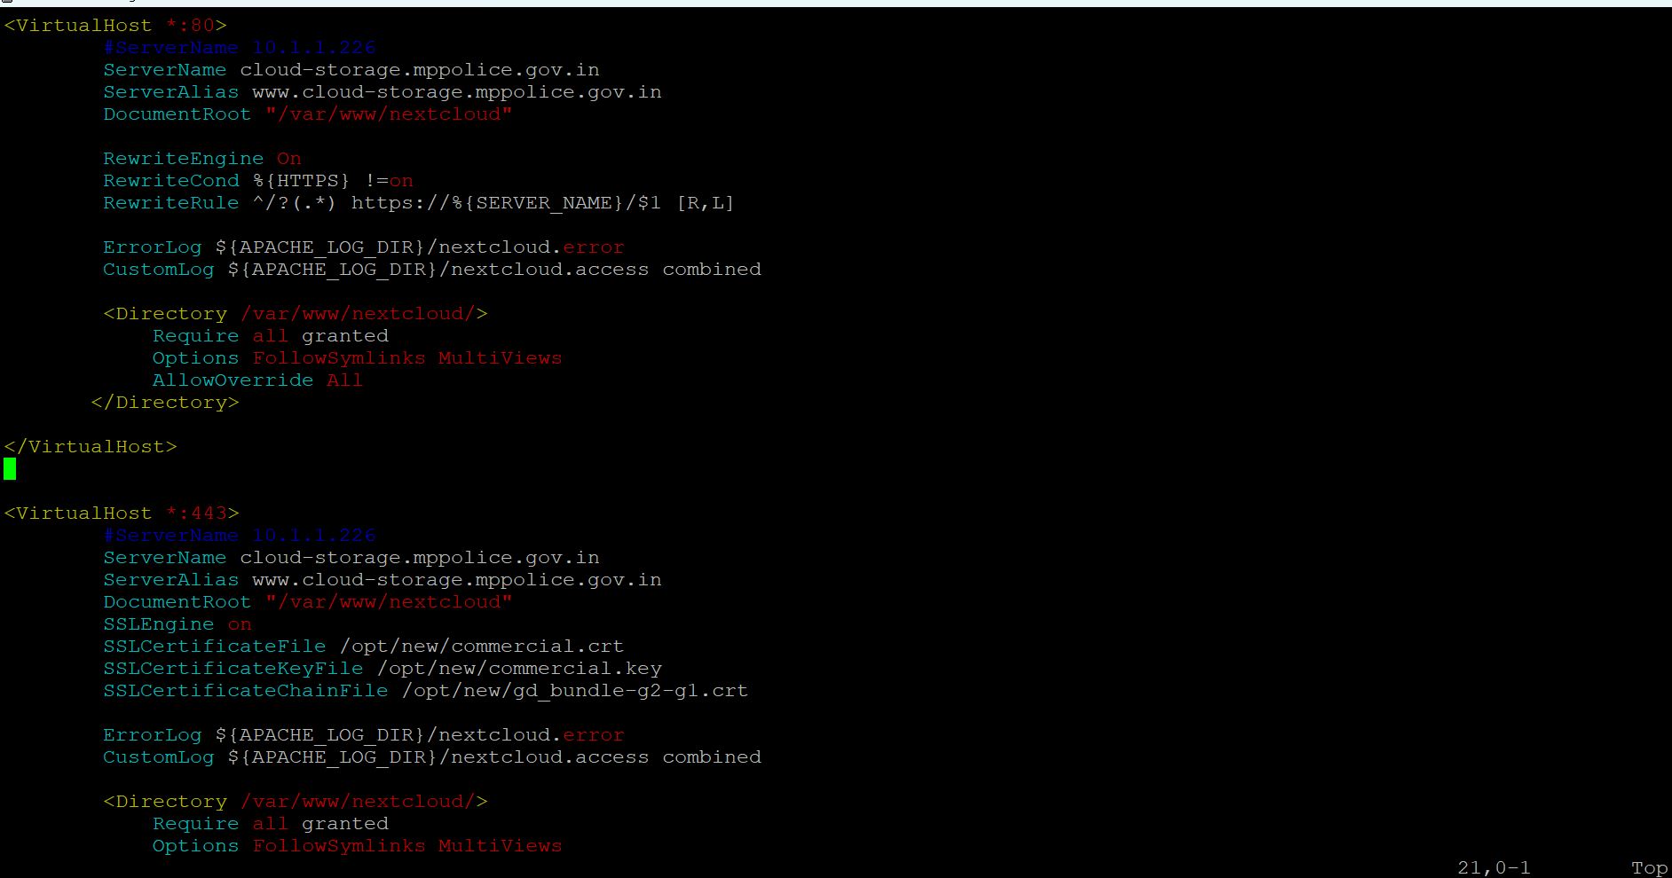

4. Disable default conf and enable nextcloud.conf
# a2dissite 000-default.conf
# a2ensite nextcloud.conf

5. Restart the apache service
# systemctl restart apache2

4. Complete Installation in GUI panel
Set Admin username & password and then enter DB username password

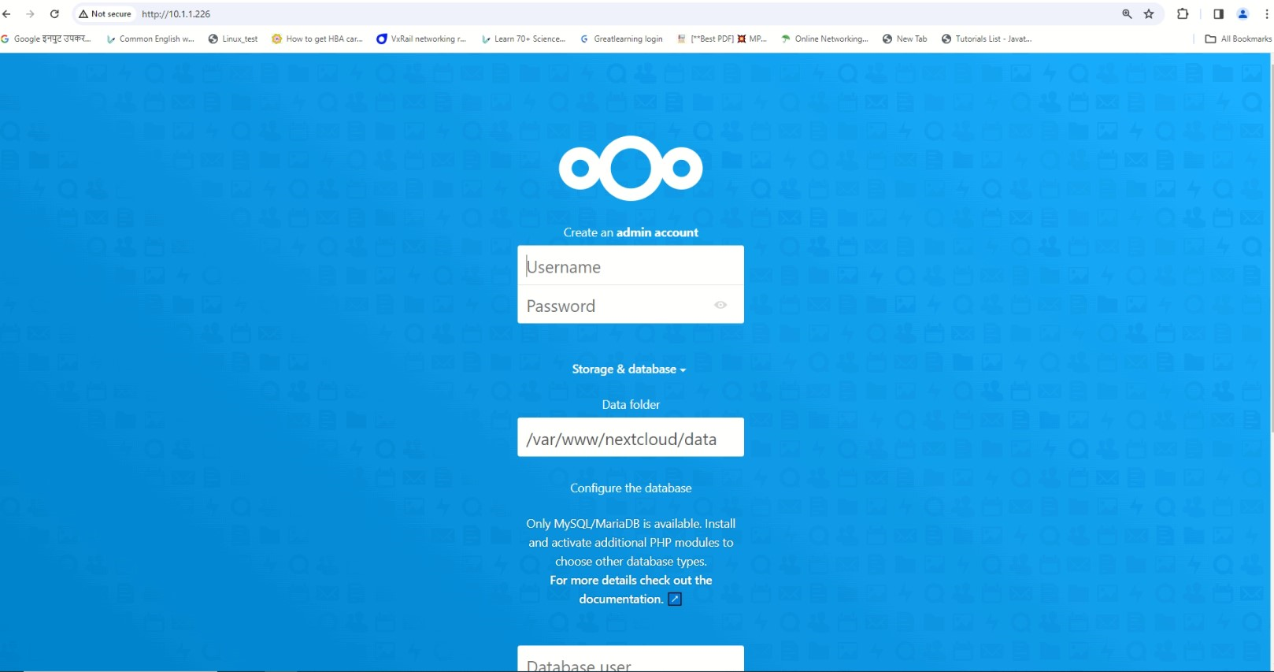
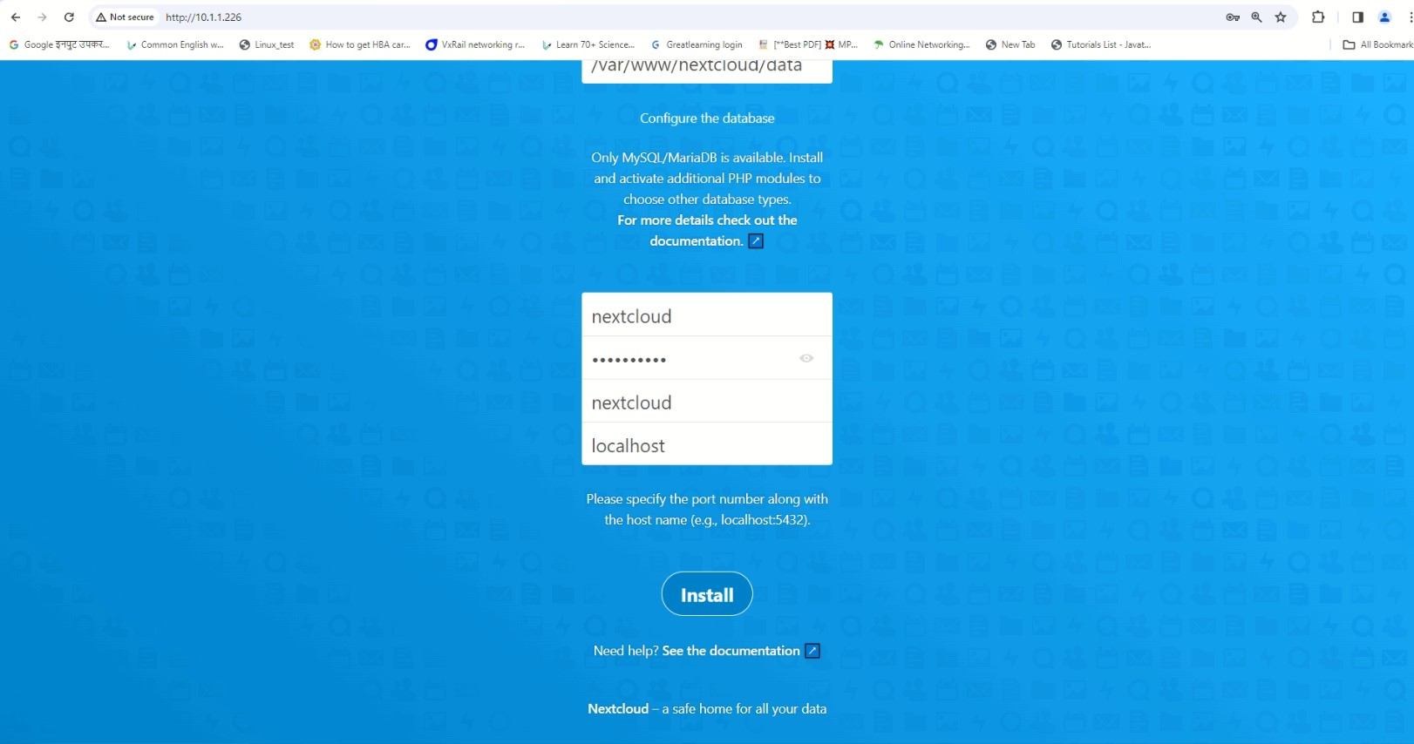

Note - Click Install to complete the installation process.

5. Deploy SSL on apache on the nextcloud server

* Copy the SSL cert, key and bundle file in /opt/new on the nextcloud server.
In the nextcloud.conf add the following lines

SSLEngine on
SSLCertificateFile /opt/new/commercial.crt
SSLCertificateKeyFile /opt/new/commercial.key
SSLCertificateChainFile /opt/new/gd_bundle-g2-g1.crt

*Restart the apache service –
systemctl restart apache2

Integrate Zimbra ldap with Nextcloud

- On nextcloud server install php-ldap
# apt install php7.4-ldap
# systemctl restart apache2
- Enable LDAP App in nextcloud and Integrate it with Zimbra ldap.
- In the LDAP/AD integration – enter the Zimbra server IP, one user details and dc names.

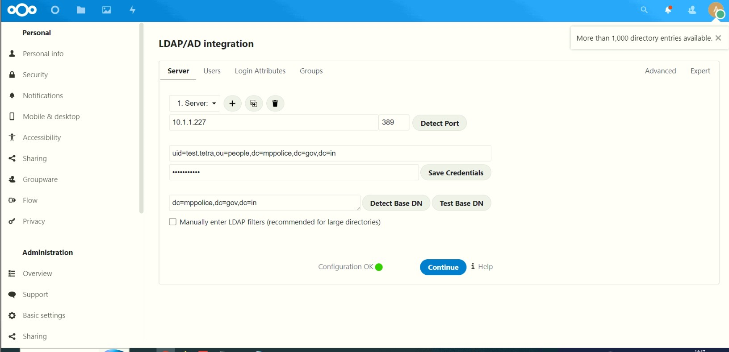

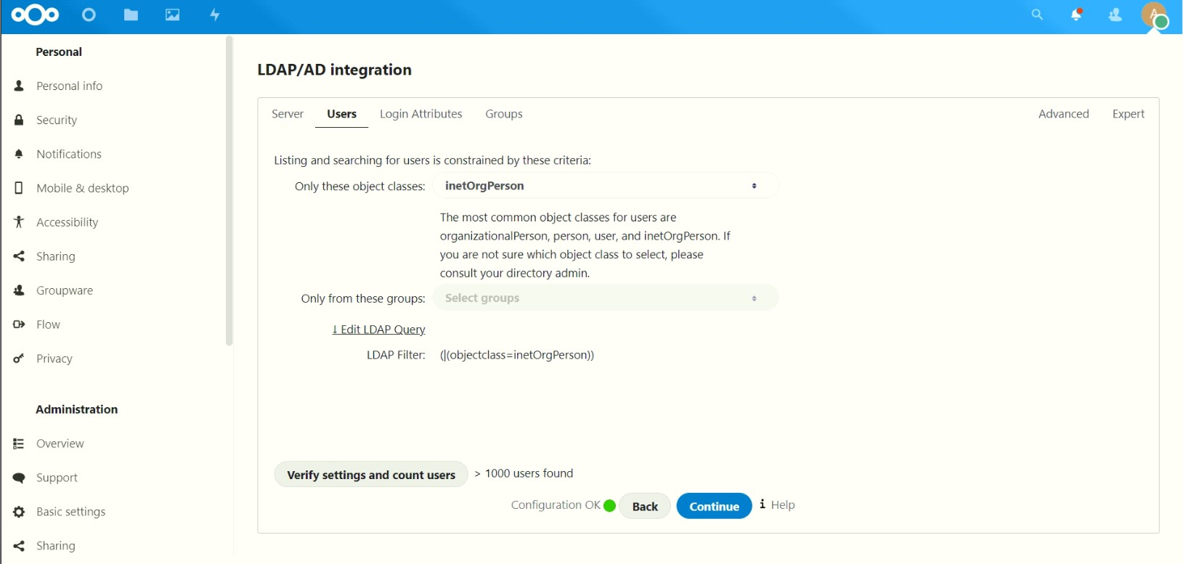
Set Directory settings –
In user display field enter - sn
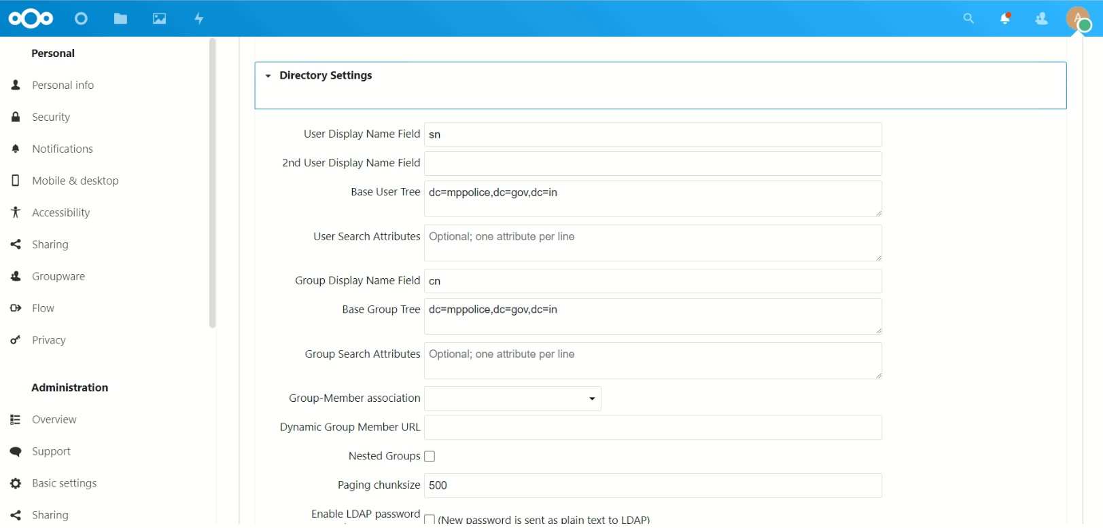

In the Expert tab –
UUID Attribute for users – enter “sn”
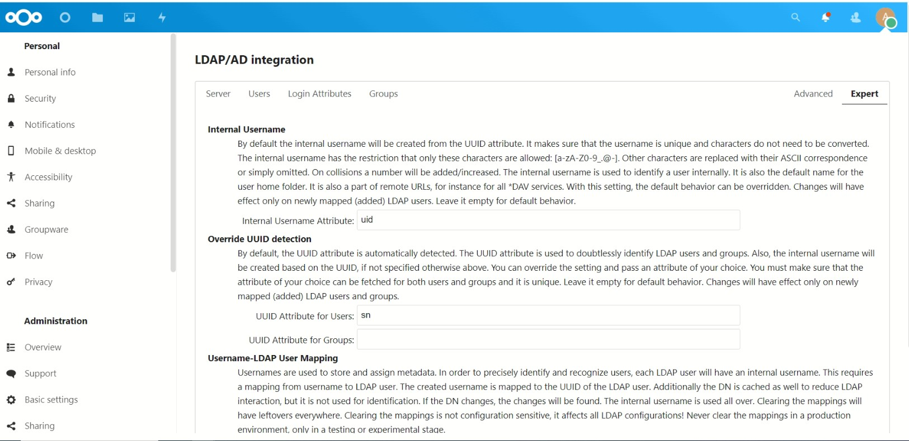

1. nextcloud admin username & password
USERNAME: admin
PASSWORD: admin123

URL: http://10.1.1.226/index.php/login

REFFERENCE URL–: http://www.mailserverguru.com/install-nextcloud-on-ubuntu-22-04/
Installing and Deploying Nextcloud zimlet on Zimbra mail server

On Zimbra server –
As root user -
Download the installer script
[root@mail ~]# wget --no-cache https://raw.githubusercontent.com/Zimbra-Community/owncloud-zimlet/soapServiceBarry/webdav-client-installer.sh -O /tmp/webdav-client-installer.sh

Change permission of the downloaded script –
[root@mail ~]# chmod +rx /tmp/webdav-client-installer.sh

Change the git url from git://github.com/ to https://github.com/
[root@mail ~]# git config --global url.https://github.com/.insteadOf git://github.com/

Execute the installer script –
[root@mail ~]# /tmp/webdav-client-installer.sh –auto

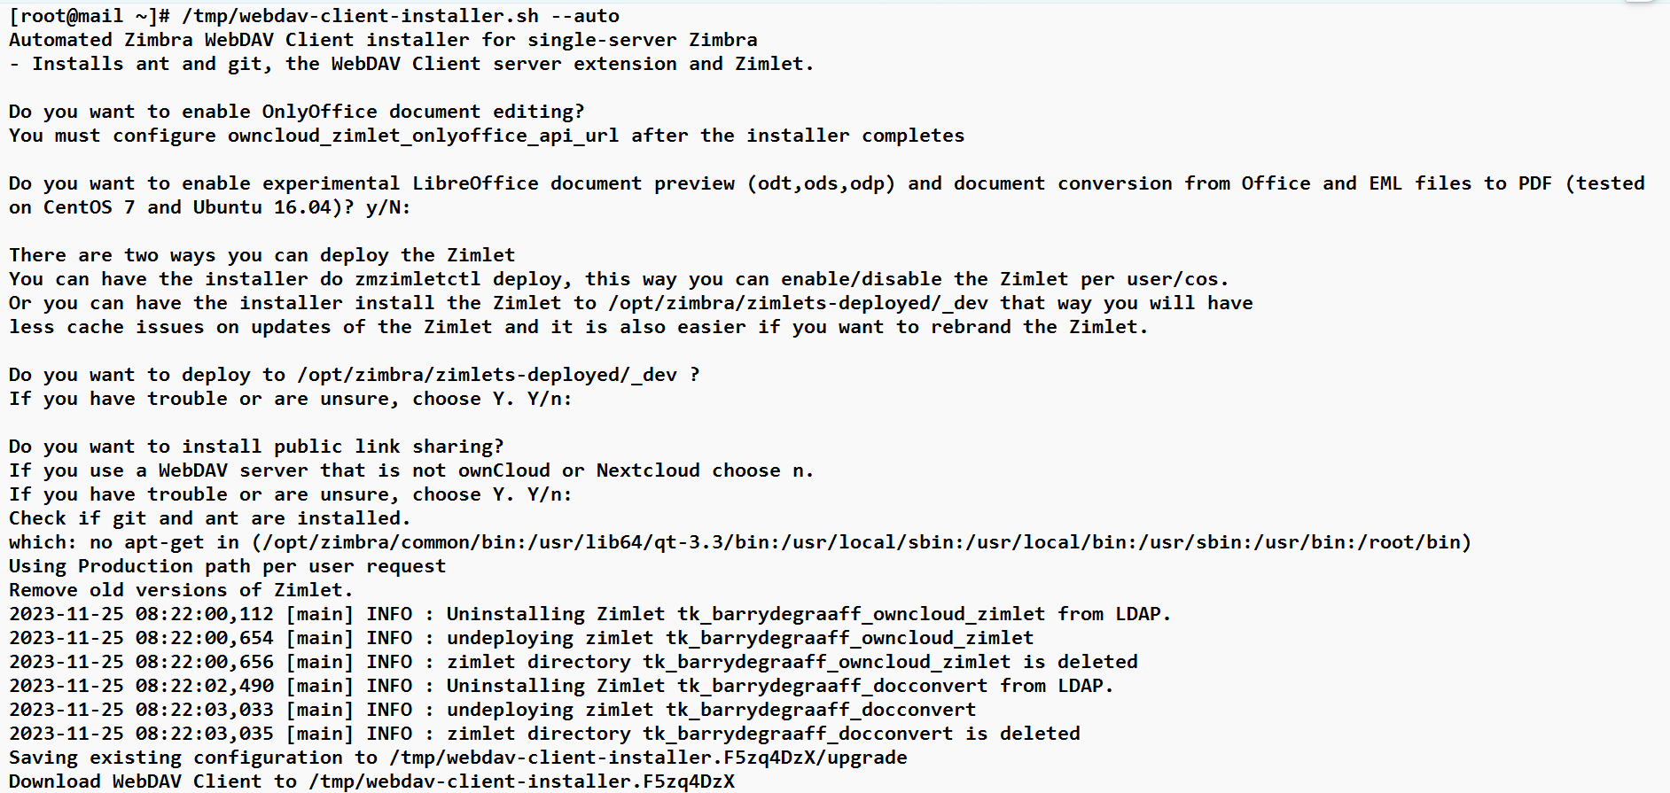

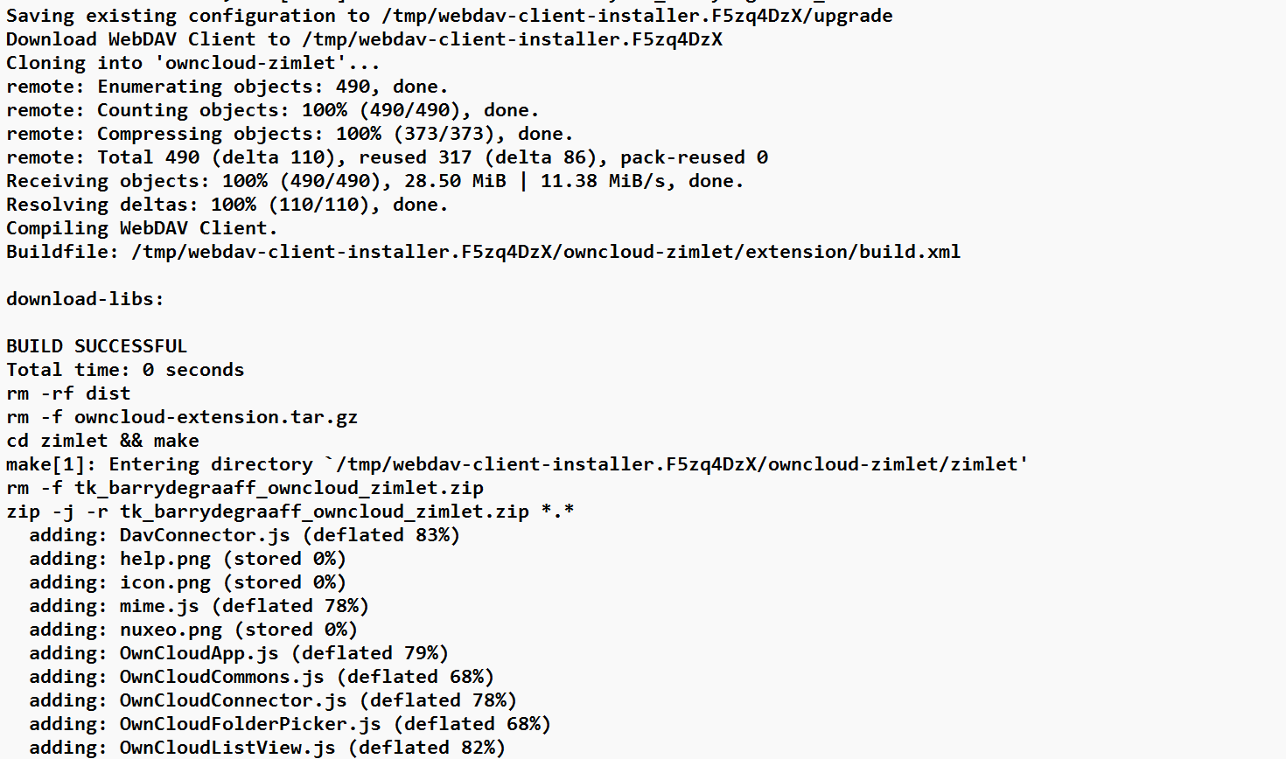

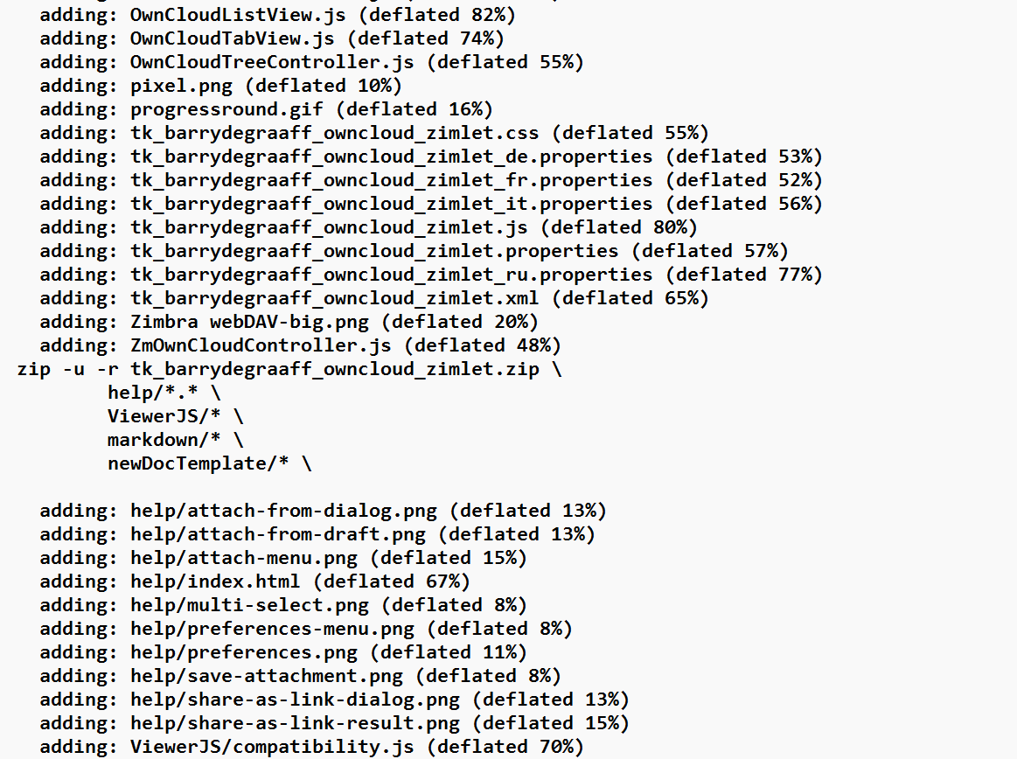

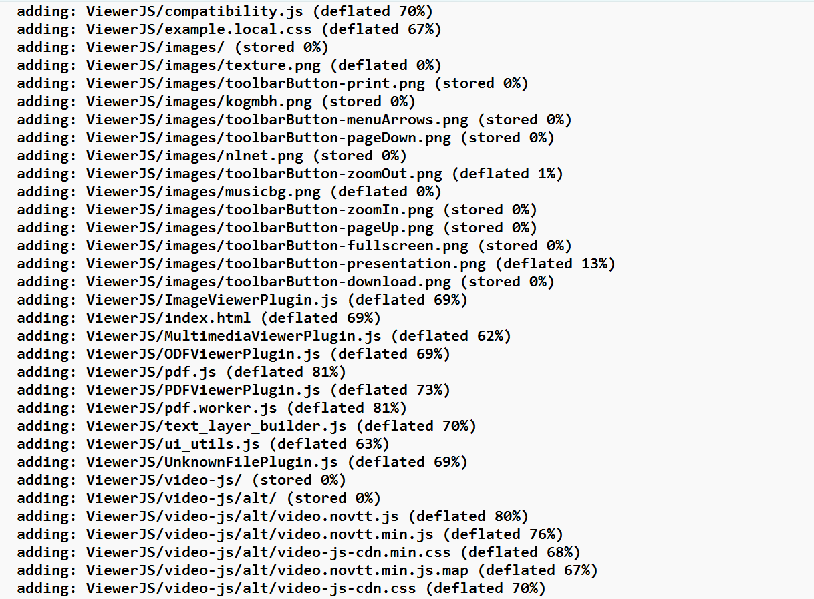

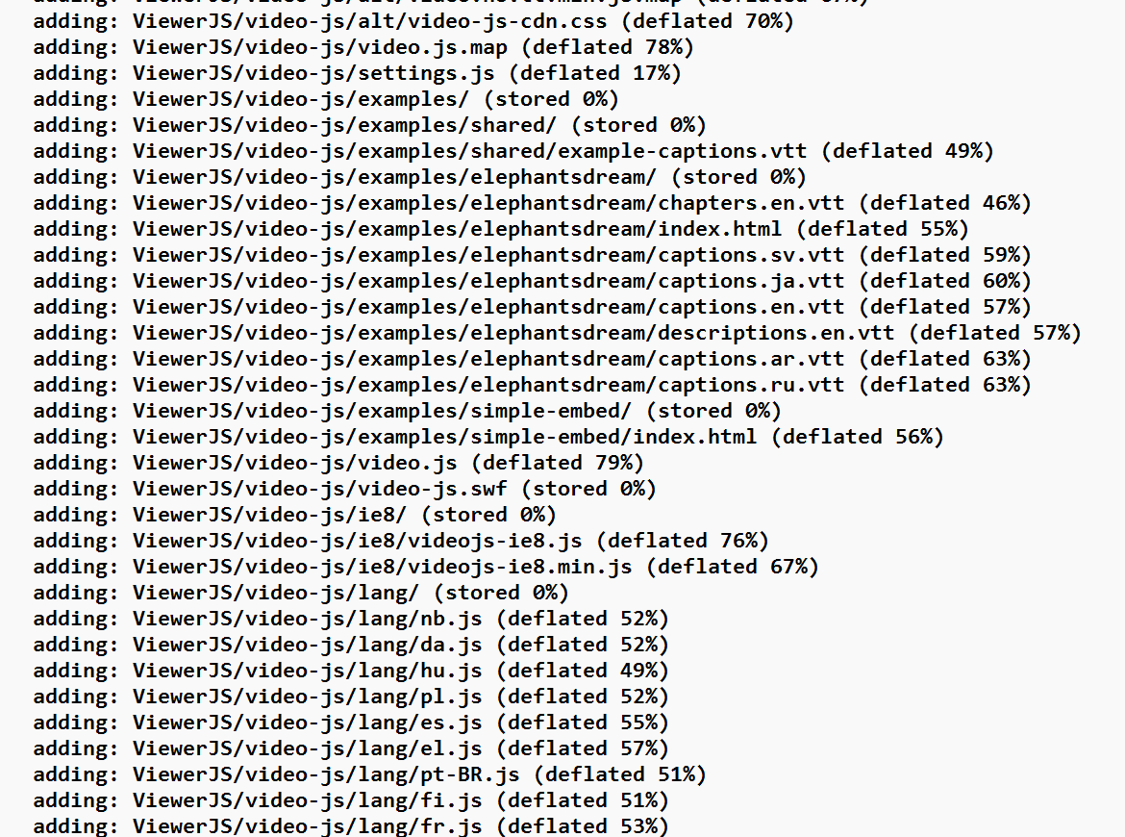

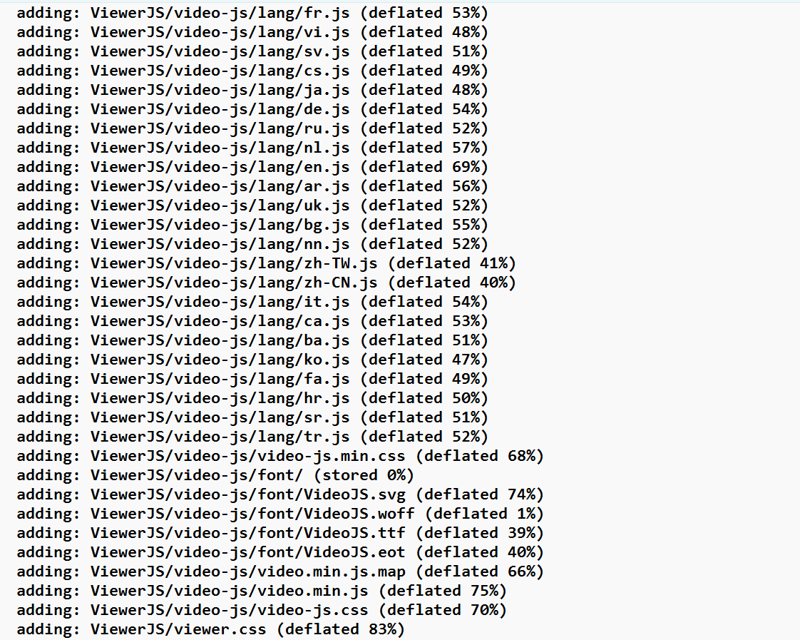

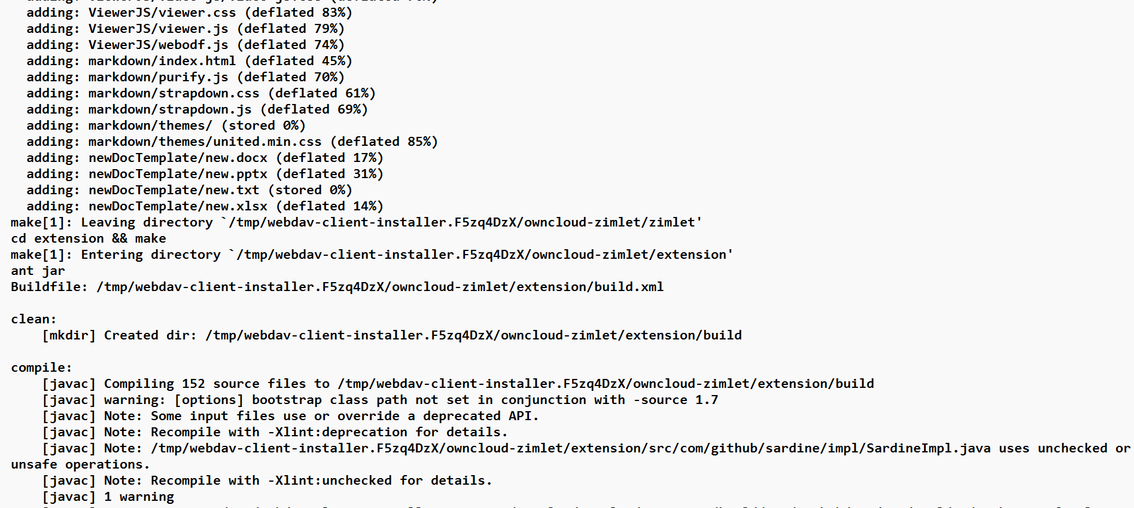

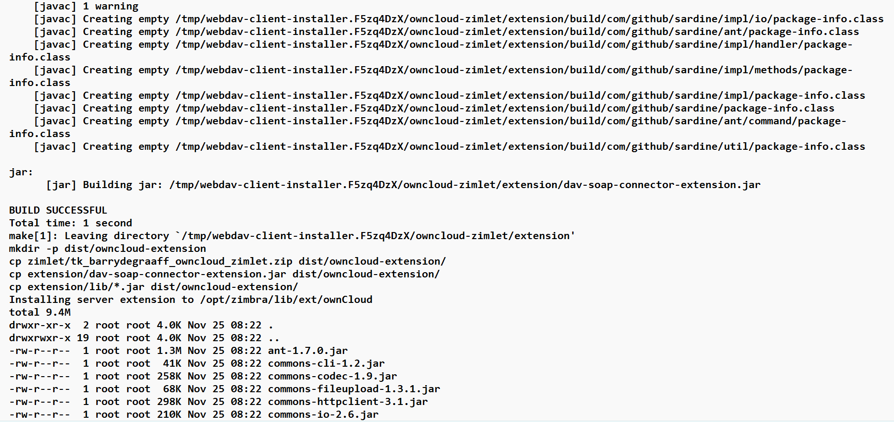

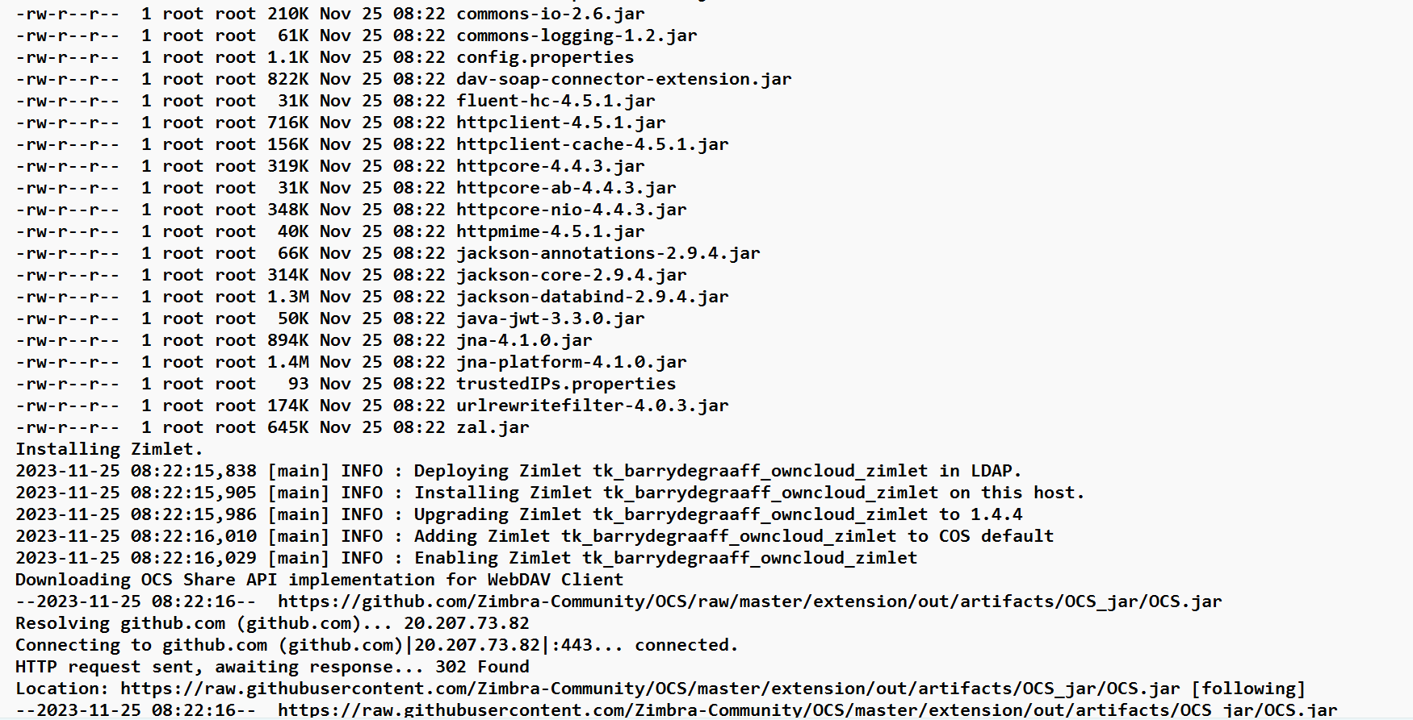

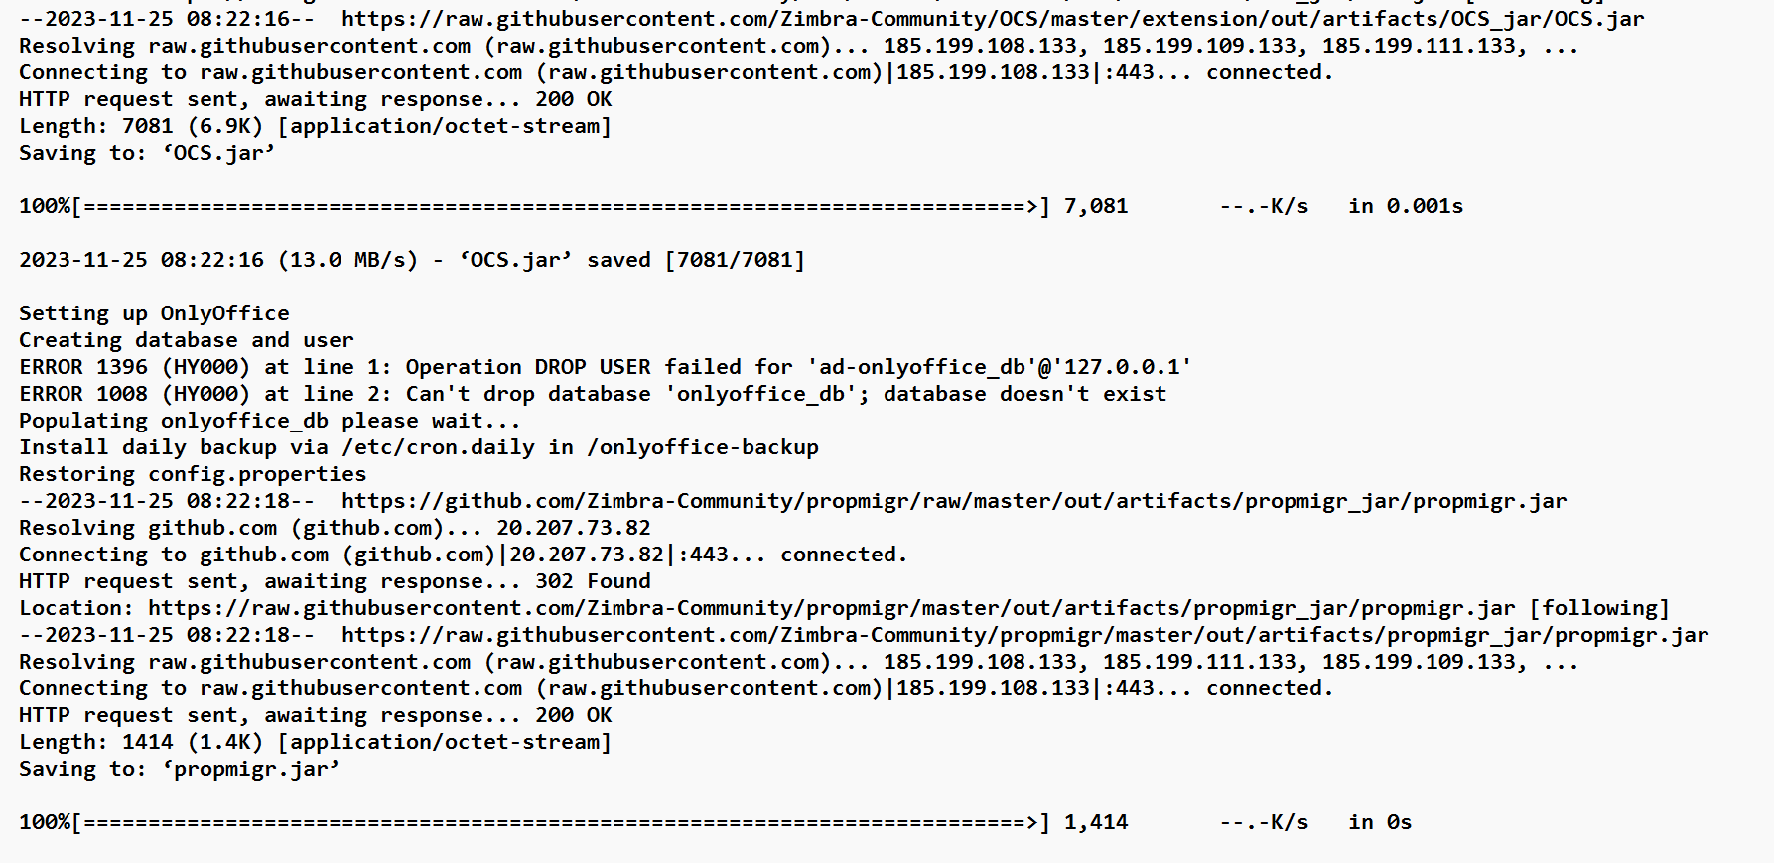

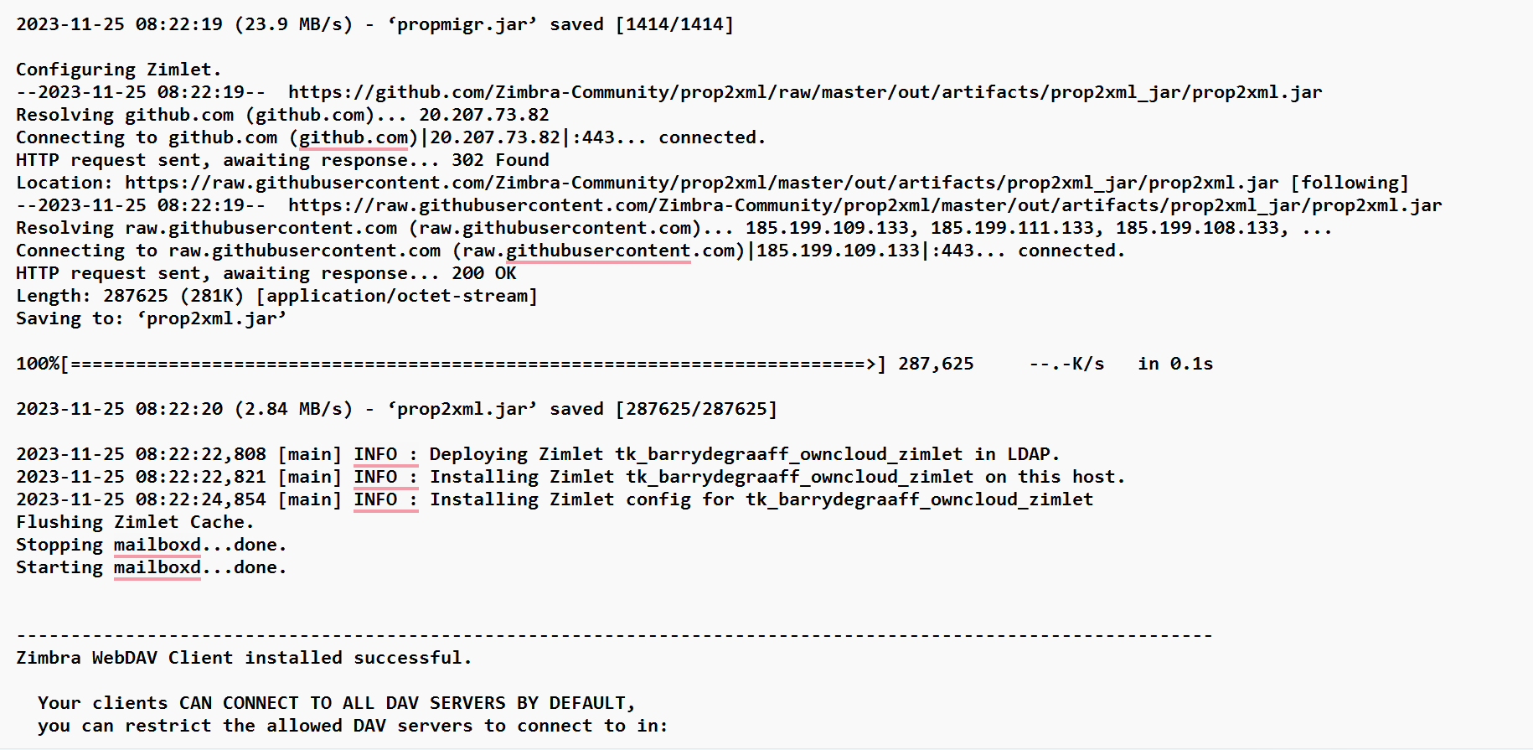

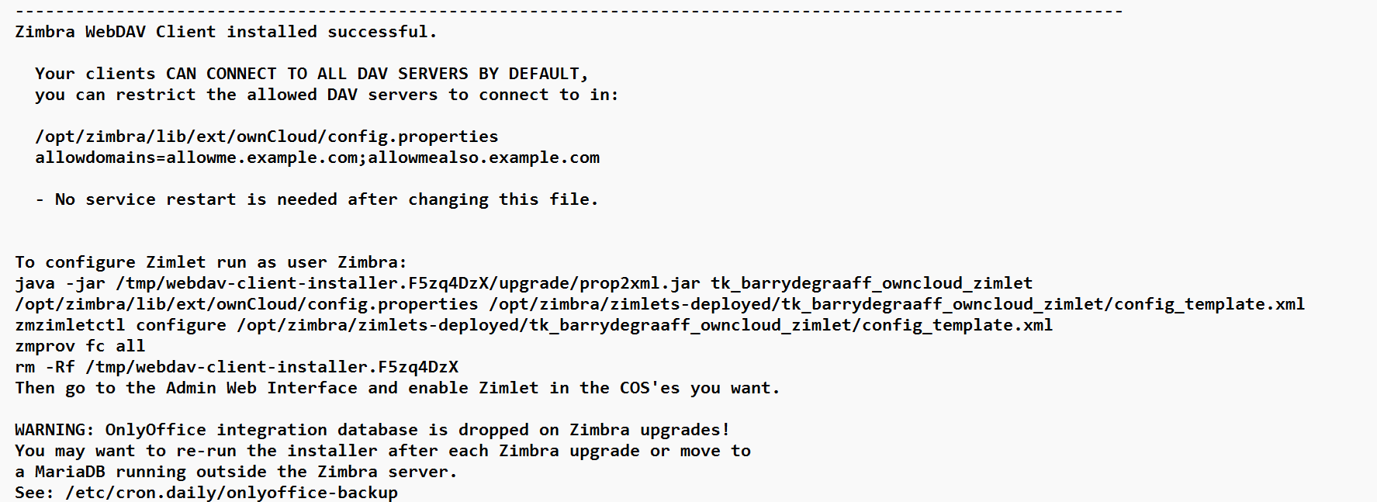

Installation and deployment completed with restarting mailbox service.

