Project Name - MP Police
Installation Of HA proxy server
Last Updated : 27th November 2023
Prepared By
Tetra Information Services Pvt. Ltd, Team

CAUTION
This document is released by Tetra Information Services Pvt. Ltd
The information contained in this document is confidential and no part of this document may be reproduced, stored in a retrieval system or transmitted in any form or by any means, electronic, mechanical, photocopying, recording or otherwise, without the prior written consent.

Document Control
Document No | Tetra_Doc3
Version No
Prepared By | Tetra Information Services Pvt. Ltd
Release Date | 27th November 2023

Revision Control Information
File Name : HA proxy server Installation .pdf

S.No | Section No | Nature of Amendment | Document Version No | Document Release Date | Remarks
1 | All | Initial |  | 3rd November 2023 | HA proxy server

Table of Contents
1 Installation of HA proxy Server
1.1
1.2
2 Dos and Donts of HA proxy Server
3 FAQ
3.1 Instalation
3.1.1 Heading2.1.1

Installation of HA proxy server

Static IP 1 - 10.1.1.232
Static IP 2- 10.1.1.233
Virtual IP- 10.1.1.234

# yum update -y
-To update yum repository
# date
# setenforce 0
# vi /etc/sysconfig/selinux
-To disable selinux
# sestatus
-To show selinux status
# systemctl status firewalld
-To check firewall status
# systemctl stop firewalld
-To stop firewall service
# systemctl disable firewalld
-To disable firewall service
# yum install wget rsync mlocate screen
-Download and Install mlocate and screen command
# reboot
# vi /etc/resolv.conf
-Set below parameter in resolv.conf file
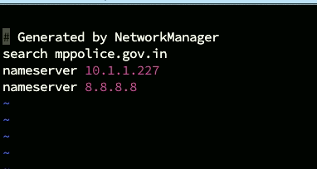
# vi /etc/hosts
-Set below parameter in hosts file
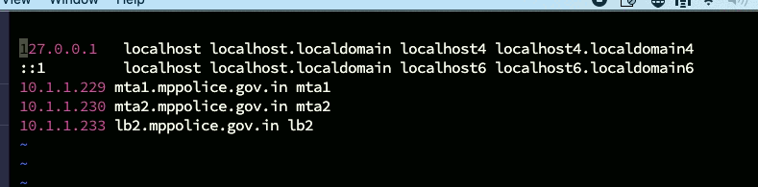

# yum install haproxy
- It is used to install the HA Proxy services
# yum install keepalived
# mv /etc/haproxy/haproxy.cfg /etc/haproxy/haproxy.cfg.org
-It rename the file haproxy.cfg to haproxy.cfg.org
# vi /etc/haproxy/haproxy.cfg
-Set below parameter in haproxy.cfg file


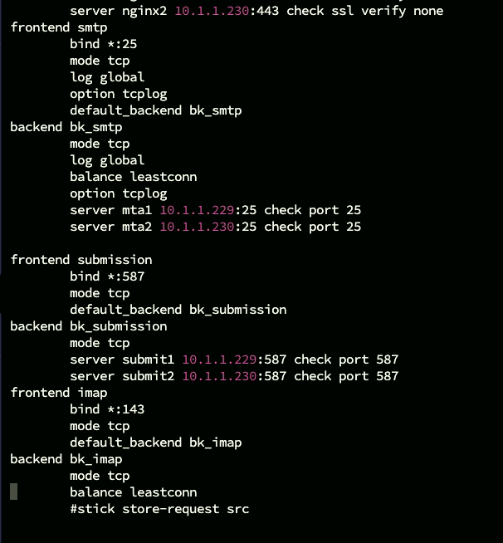



# mv /etc/keepalived/keepalived.conf /etc/keepalived/keepalived.conf.org
--It rename the file keepalived.conf to keepalived.conf.org
# vi /etc/keepalived/keepalived.conf
-Set following parameter in keepalived.conf



# systemctl status haproxy
-To show the haproxy service status
# systemctl start haproxy
-To start the haproxy service
# systemctl enable haproxy
-To permanent enable the haproxy service
# systemctl status keeplived
-To show the keeplived service status
# systemctl start keepalived
-To start the keepalived service
# systemctl enable keepalived
-To permanent enable the keepalived service

# systemctl status keepalived
- To show the keeplived service status

