Active sync Server Presentation Docs
How to sync Mail on Mobile
Steps : -
Go to the Gmail Icon Settings Add account Exchange and Office 365 Enter email address Enter Paswword Change server name

Step -1 Go to Gmail icon and double click
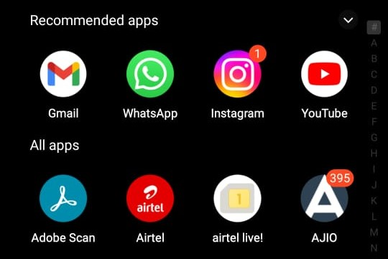

Step -2 Go to Setting option and click on it
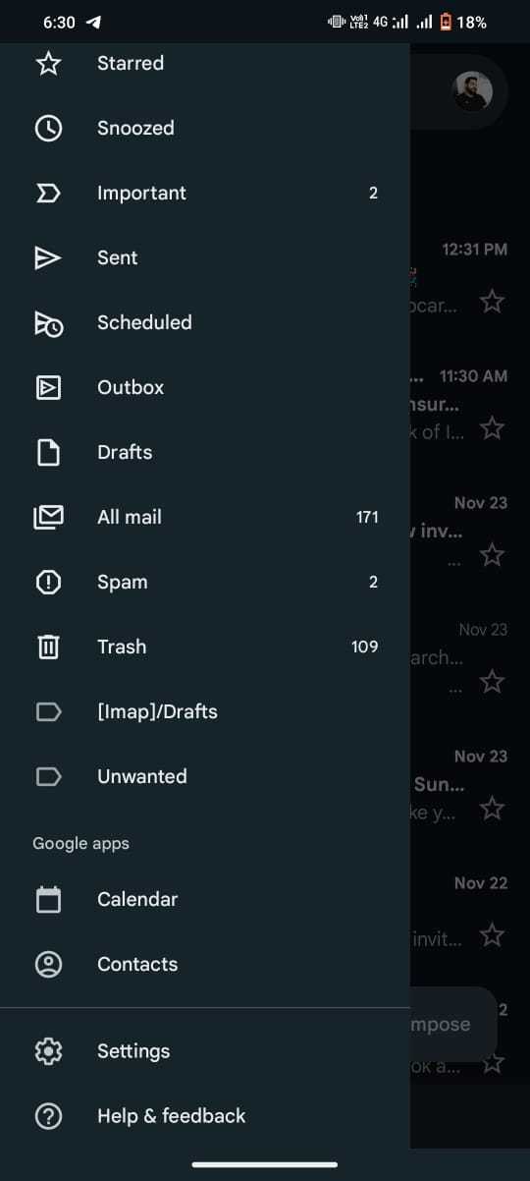

Step -3 Go to Add account option and click on it
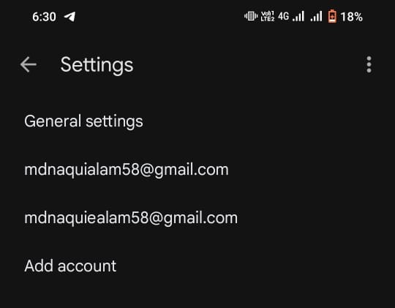

Step -3 Go to Exchange and Office 365 and click on it
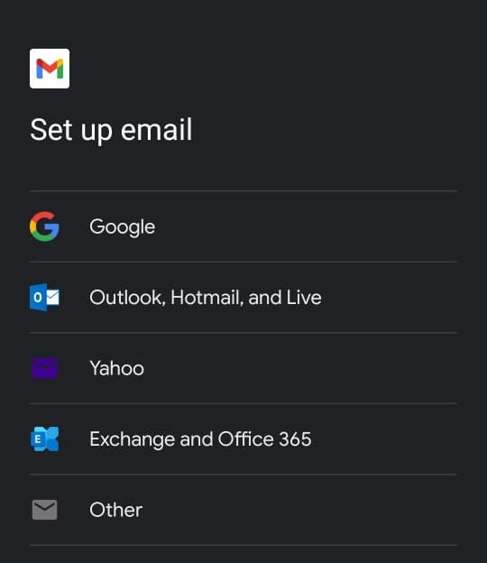

Note – Go to the manually acount option and Enter Email id and Password which we have to add or sync on mail accordingly
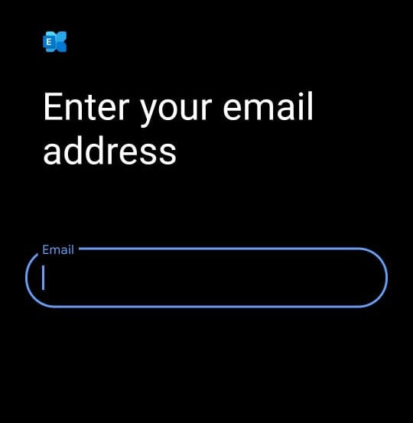
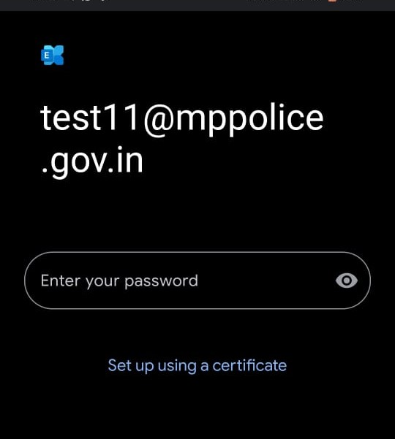

Note – Change the server name which are mention below

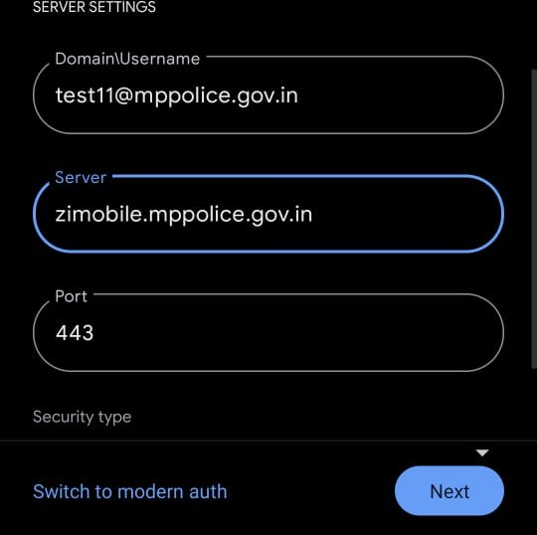
-Now It take some time and sync all the mail on mobile.

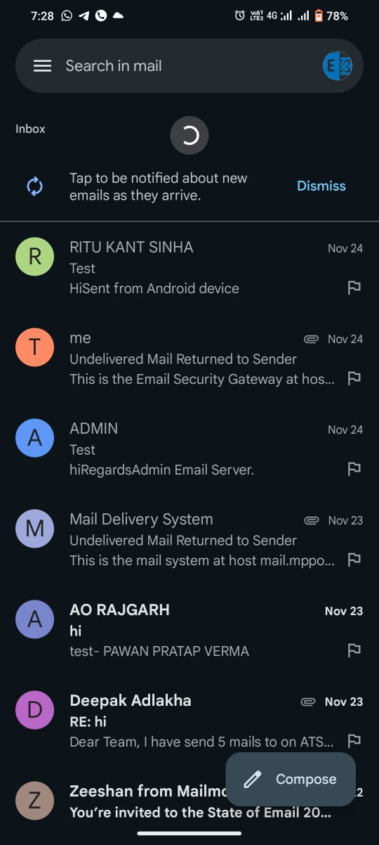
It shows in this format as like Gmail
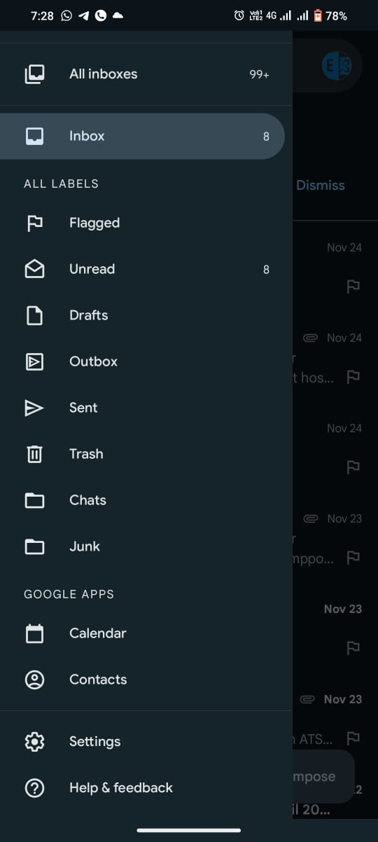

How to Log in Mail on Mobile by Web browser
Steps:
Step – 1 Go the google and type which is mention in search bar
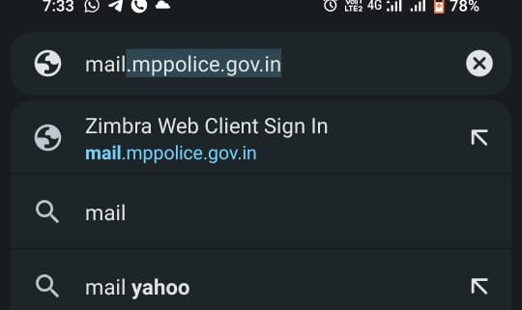
- It open a console which is mention below
Step -2 Enter username and Password accordingly
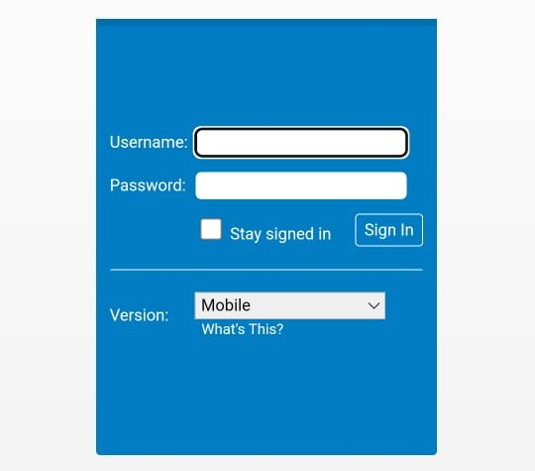
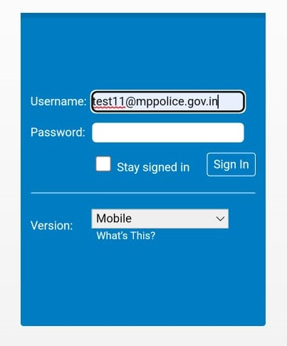

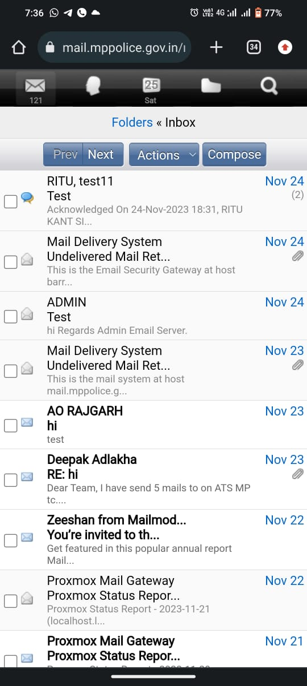

Note –
- It gives a gmail like smooth Interface in which all Option are available in one Interface
- It gives a calander option
- It gives contact and Task option and many more
- Fast syncronise with server

Benefits to Integrate Active Sync Server
- Mobile Integration with Active Sync Server
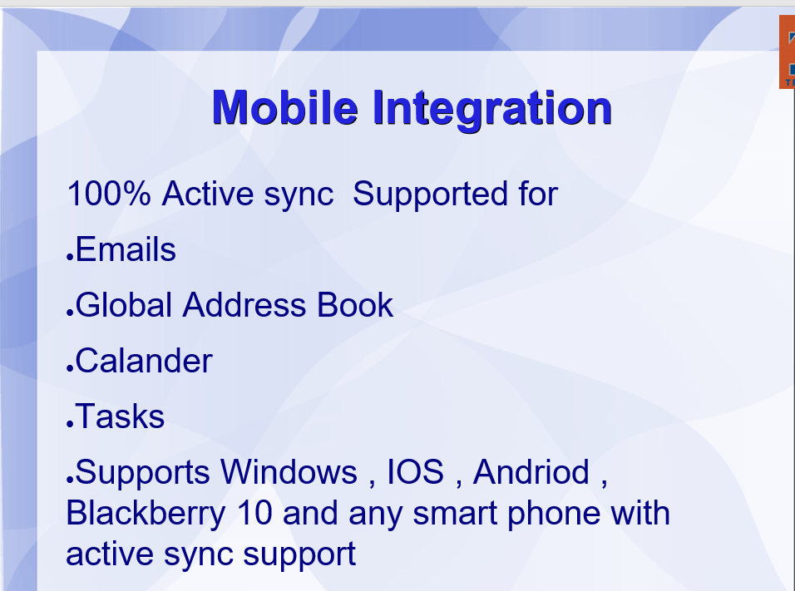

- Outlook Integration with Active Sync Server

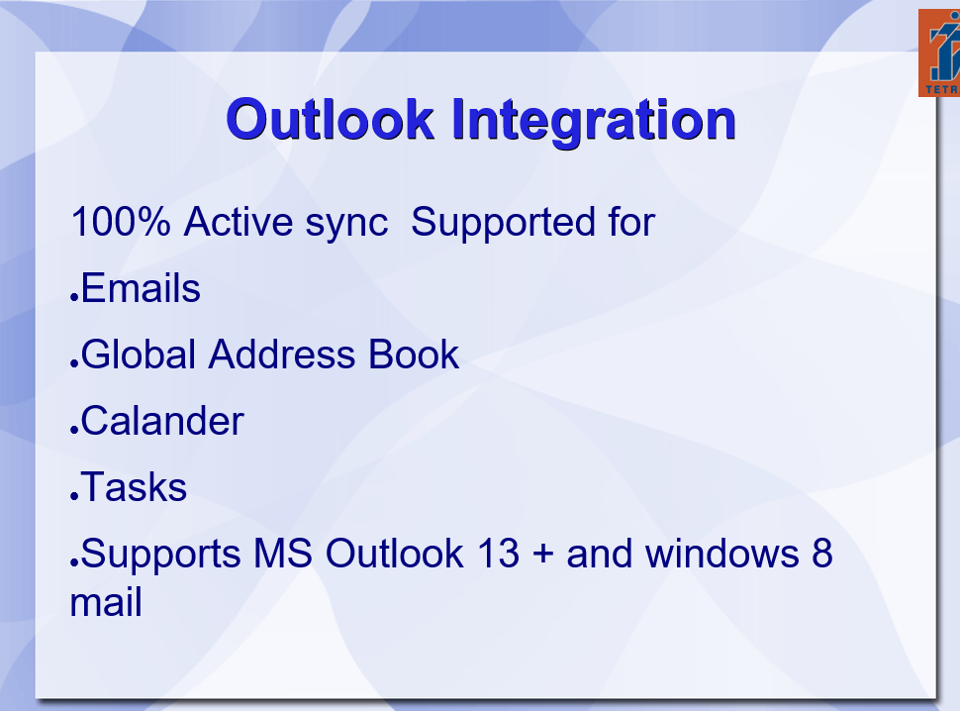

- Thunderbird Integration with Active Sync Server

