ZIMBRA TO M365 MIGRATION

- In the new Exchange Admin center at https://admin.exchange.microsoft.com/#/, go to Migration and then select Add migration batch.
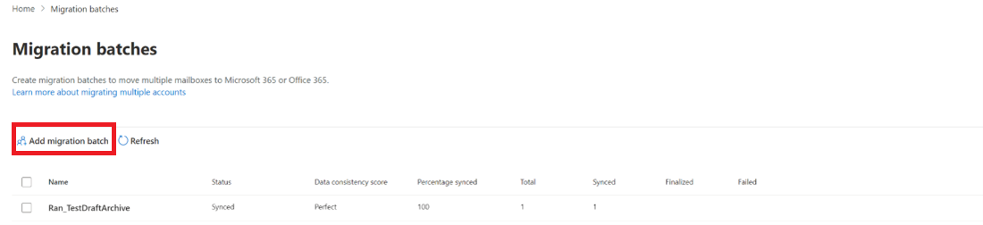
- The Add migration batch
- Configure the following settings:
- Give migration batch a unique name: Enter a unique name.
- Select the mailbox migration path: Verify that Migration to Exchange Online is selected.
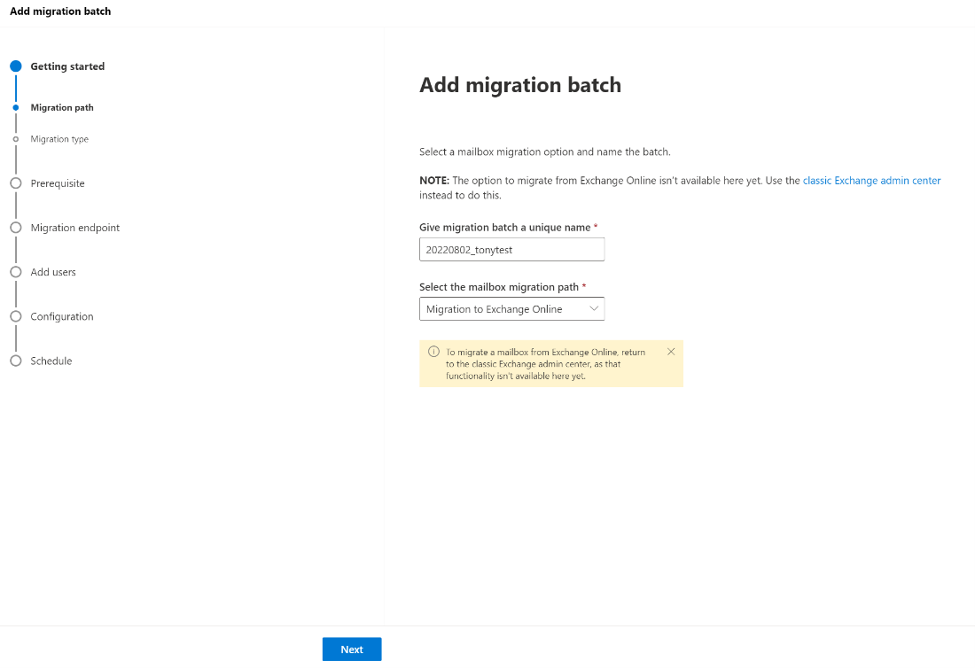
- When you're finished, select Next
- Select Imap migration, and then select Next.
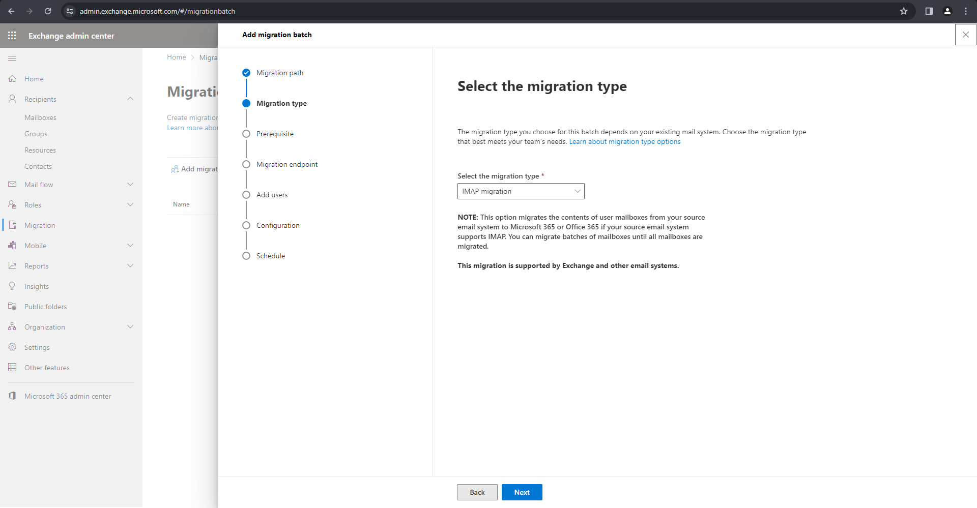

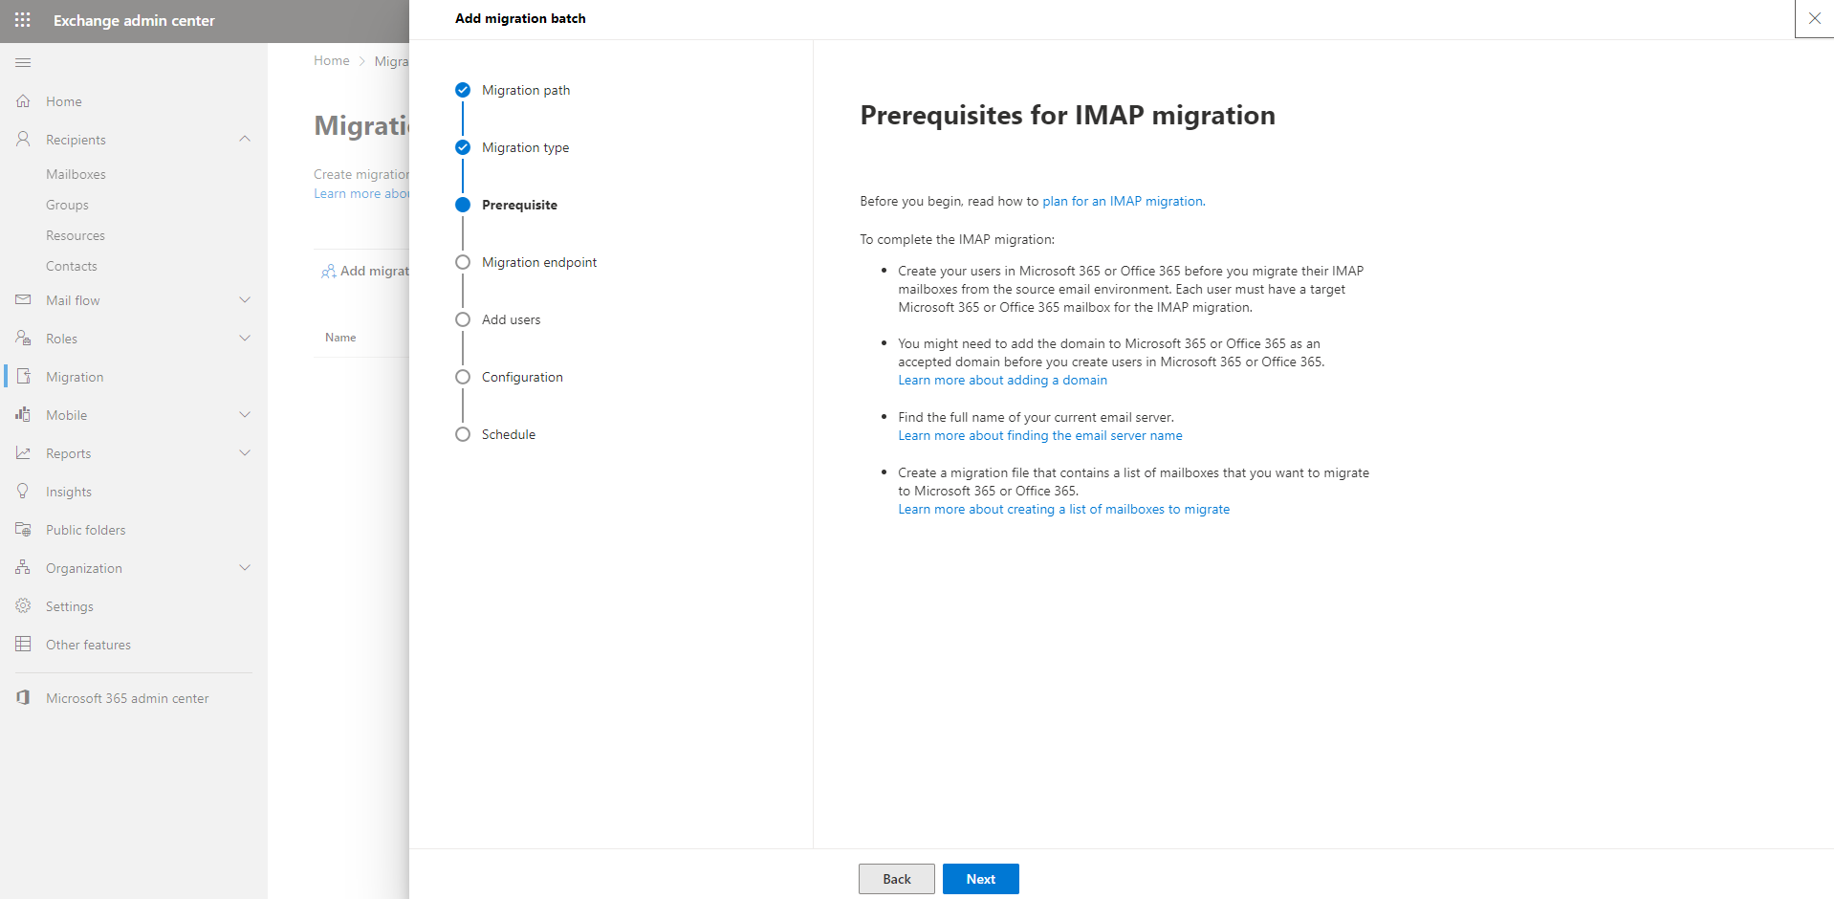

- Create migration endpoint
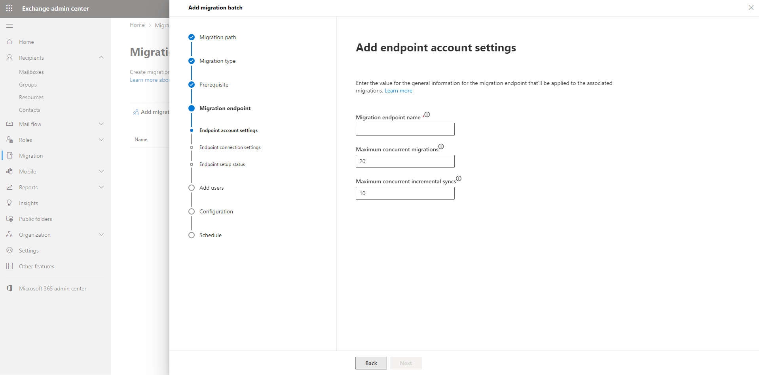

- Download and save one of the CSV files below. Open it in Excel or a similar app and add your users’ information. Upload the file below and we’ll verify it’s formatted correctly.
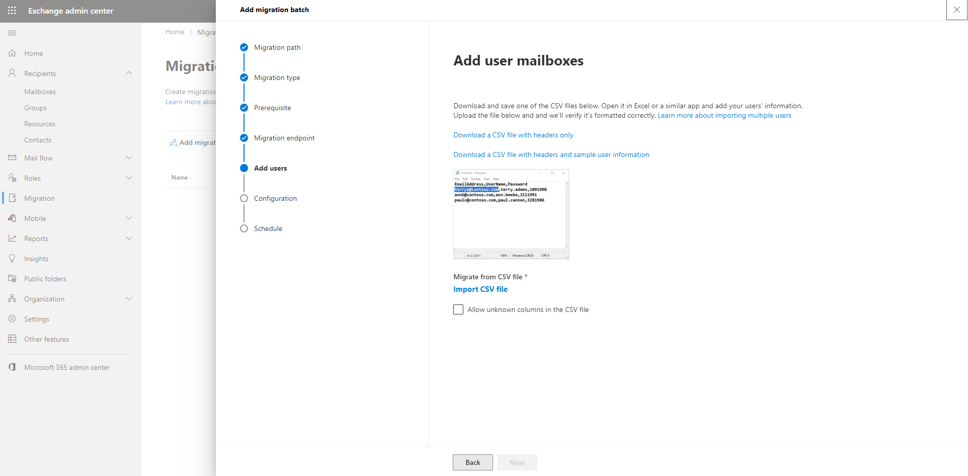

- From the Target delivery domain drop-down list, select the target delivery domain
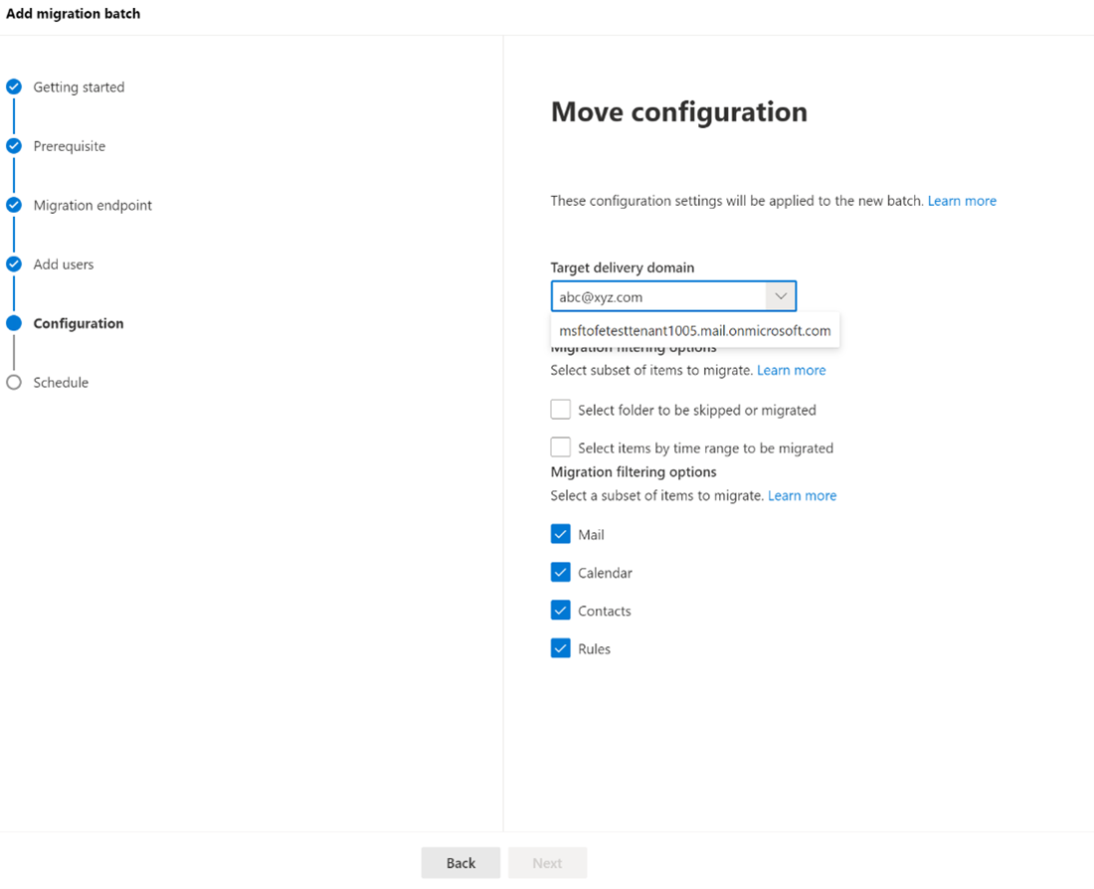

9. On the Schedule batch migration page, verify all the details, select Save, and then select Done.
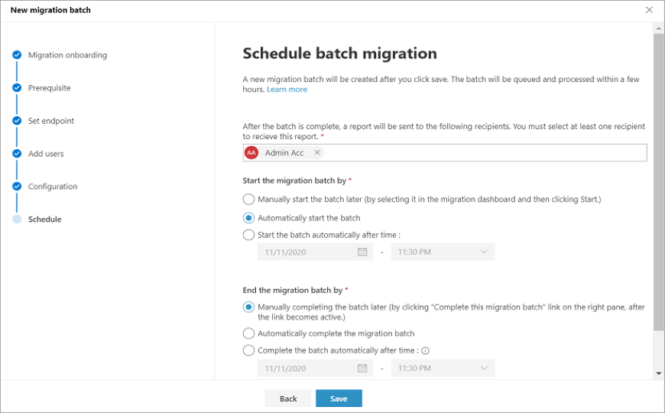

################################################################
Outbound connector

*Set up a connector from Microsoft 365 or Office 365 to your email server

- Navigate to Mail flow > Connectors. The Connectors screen appears.
- Click + Add a connector. The New connector screen appears.
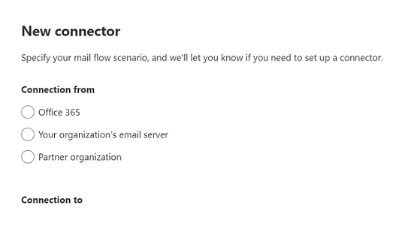
- Under Connection from, choose Office 365.
- Under Connection, choose Your organization's email server.
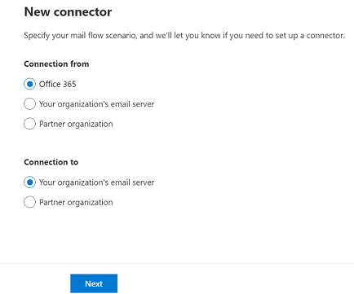
- Click Next. The Connector name screen appears.
- Provide a name for the connector and click Next. The Use of a connector screen appears.
- Choose an option that determines when you want to use the connector, and click Next. The Routing screen appears
- Enter the domain name or IP address of the host computer to which Office 365 will deliver email messages.
- Click +.
- Click Next. The Security Restrictions screen appears.
- Define the settings by:
*Checking the check box for Always use Transport Layer Security (TLS) to secure the connection.
*Choosing any one of the two options under Connect only if the
recipient's email server certificate matches these criteria.
*Clicking Next, on which the Validation email screen appears.
- Enter an email that belongs to the mailbox of your organization's domain.
- Click +.
- Click Validate. The connector validation process starts.
- Once the validation process is completed, click Next. The Review connector screen appears.
- Review the settings you have configured and click Create Connector.

################################################################

###############################################################
If all steps are completed and all emails sync successfully then follow the below steps on Zimbra.

- zmprov md sceh.net zimbraMailCatchAllAddress @sceh.net zimbraMailCatchAllForwardingAddress @sceh.net zimbraMailTransport smtp:sceh-net.mail.protection.outlook.com:25

##############################################################

##################Setup domain manually######################
Follow these steps to add, set up, or continue setting up a domain.

- Go to the Microsoft 365 admin center.
- Go to the Settings > Domains page.
- Select Add domain.
- Enter the name of the domain you want to add, then select Next.
- Choose how you want to verify that you own the domain.

You can use a TXT record to verify your domain. Select this and select Next to see instructions for how to add this DNS record to your registrar's website. This can take up to 30 minutes to verify after you've added the record.
You can add a text file to your domain's website. Select and download the .txt file from the setup wizard, then upload the file to your website's top level folder. The path to the file should look similar to: http://mydomain.com/ms39978200.txt. We'll confirm you own the domain by finding the file on your website.
Choose how you want to make the DNS changes required for Microsoft to use your domain.

Choose I'll add the DNS records myself if you want to attach only specific Microsoft 365 services to your domain or if you want to skip this for now and do this later. Choose this option if you know exactly what you're doing.
If you choose to add DNS records yourself, select Next and you'll see a page with all the records that you need to add to your registrars website to set up your domain.

*Follow the steps below to add a custom record for a website or 3rd party service.

- Sign in to the Microsoft 365 admin center.
- Go to the Settings > Domains page.
- On the Domains page, select a domain.
- Under DNS records, select Custom Records; then select Add record.
- Select the type of DNS record you want to add and type the information for the new record.

