Zimbra Upgradation Document

Zimbra Upgration from zimbra 8.0.5 to zimbra 8.8.15 on centos 6.10

Admin url: https://mail.mppolice.gov.in:7071/zimbraAdmin/

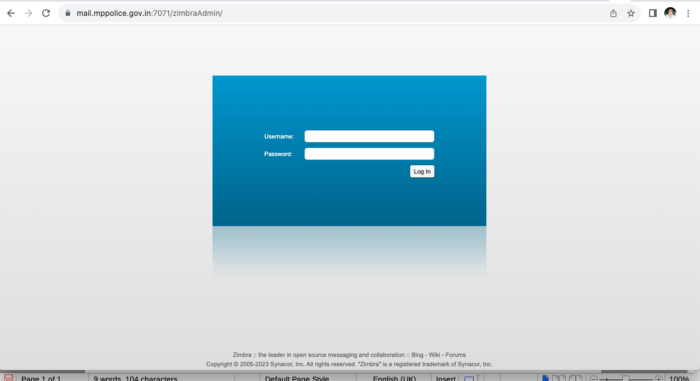
- Login by Admin username and Password

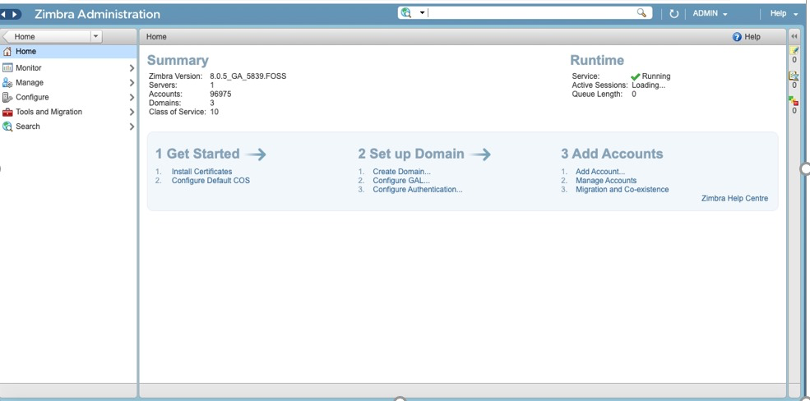

First upgrade zimbra from zimbra 8.0.5 to 8.6.0 on Centos 6.10

As a root

1. first download tar file of zimbra 8.6.0 for Centos 6

2. Extracted tar file as mention below
# tar -xvzf zcs-8.6.0_GA_1153.RHEL6_64.20141215151155.tgz

3. Then go to the mention directory as below
# cd zcs-8.6.0_GA_1153.RHEL6_64.20141215151155

4. Run the below script which is mention below
# ./install.sh
-Choose option accordingly after script run

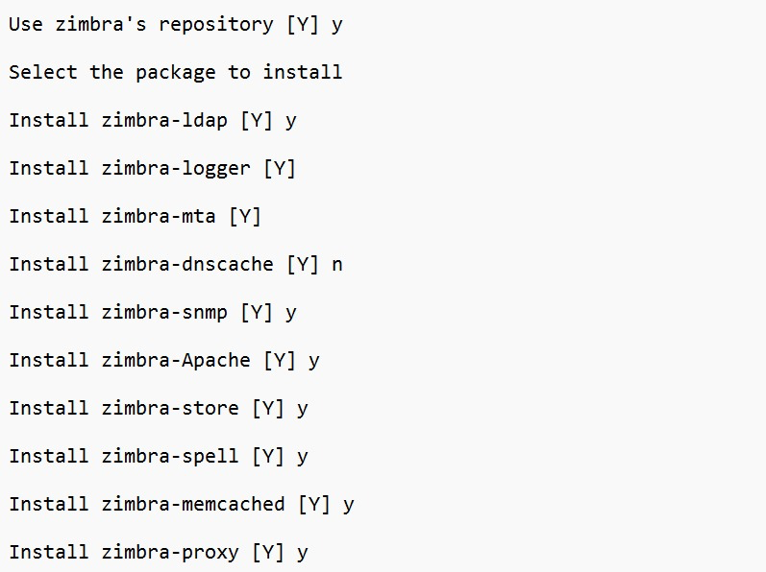
5. Now switch as a zimbra user by given command which is mention below
# su – zimbra

6. restart zimbra services by given command which is mention below.
# zmcontrol restart

7. Now reboot the VM by the given command
# reboot

8. Now check the zimbra version as a zimbra user
# zmcontrol -v
Release 8.6.0_GA_1153.RHEL6_64.20141215151155

Now Upgrade zimbra from zimbra 8.6.0 to zimbra 8.7.11 on Centos 6.10

Note – Follow the same process which are mention above

- Download tar file of zimbra 8.7.11 for Centos 6

# tar -xvzf zcs-8.7.11_GA_1854.RHEL6_64.20170531151956.tgz
# cd zcs-8.7.11_GA_1854.RHEL6_64.20170531151956
# ./install.sh
-Choose option accordingly after script run
# su – zimbra
# zmcontrol restart
# reboot
# # zmcontrol -v
Release 8.7.11_GA_1153.RHEL6_64.20141215151155

Now Upgrading zimbra from zimbra 8.7.11 to zimbra 8.8.15 on centos 6.10

Note – Follow the same process which are mention above

- Download tar file of zimbra 8.8.15 for Centos 6

# tar -xvzf zcs-8.8.15_GA_3869.RHEL6_64.20190918004220.tgz
# cd zcs-8.8.15_GA_3869.RHEL6_64.20190918004220
# ./install.sh
-Choose option accordingly after script run
# su – zimbra
# zmcontrol restart
# reboot
# zmcontrol -v
Release 8.8.15_GA_1153.RHEL6_64.20141215151155

Now Upgrade zimbra 8.8.15 on centos 7.9

Note – Follow the same process which are mention above

- Download tar file of zimbra 8.8.15 for Centos 7

# tar -xvzf zcs-8.8.15_GA_3869.RHEL7_64.20190918004220.tgz
# cd zcs-8.8.15_GA_3869.RHEL7_64.20190918004220
# ./install.sh -s
# su - zimbra
# systemctl status postfix
# systemctl stop postfix
# systemctl disable postfix
# systemctl status postfix
# su – zimbra
# zmcontrol restart
# zmcontrol -v
Release 8.8.15_GA_1153.RHEL7_64.20141215151155

Now Update zimbra patch to latest patch on centos 7.9

# yum install zimbra-common-core-jar zimbra-common-core-libs zimbra-mbox-store-libs zimbra-ldap-patch zimbra-proxy-patch zimbra-snmp-components zimbra-mta-components zimbra-snmp-components zimbra-mta-patch zimbra-common-core-jar zimbra-common-core-libs zimbra-mbox-store-libs zimbra-patch zimbra-apache-components zimbra-spell-components

# yum update
# su – zimbra
# zmcontrol restart
# zmcontrol status
# zmcontrol -v
Release 8.8.15_GA_3869.RHEL7_64_20190917004220 RHEL7_64 FOSS edition, Patch 8.8.15_P44.

Admin url: https://mail.mppolice.gov.in:7071/zimbraAdmin/

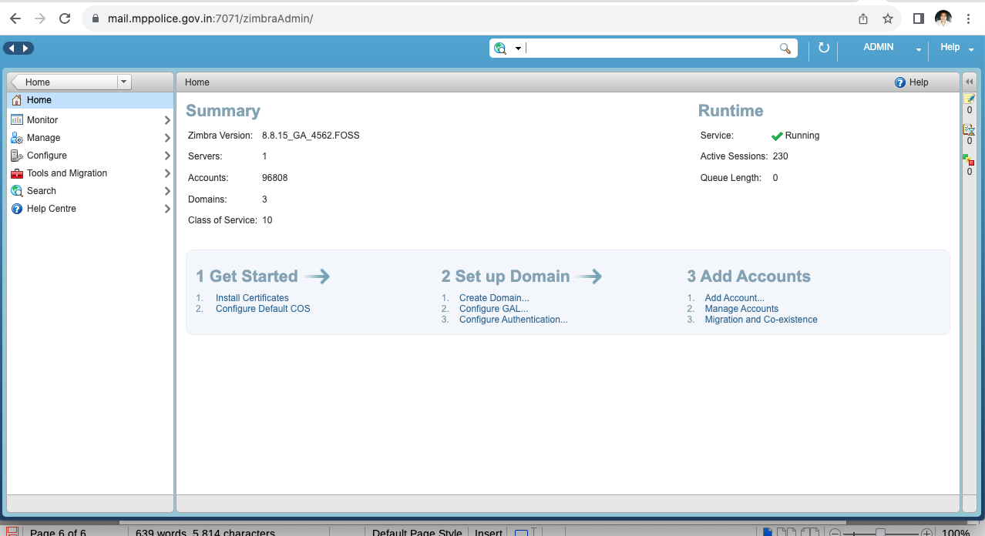

User url: mail.mppolice.gov.in

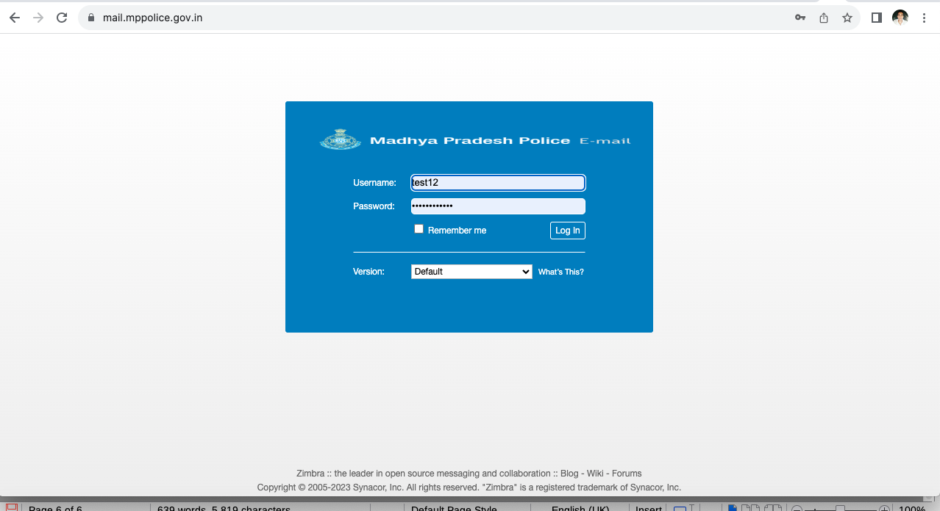
Now Login Succsessful



