Jitsi Presentation Documentation

url: https://zivideo.mppolice.gov.in/
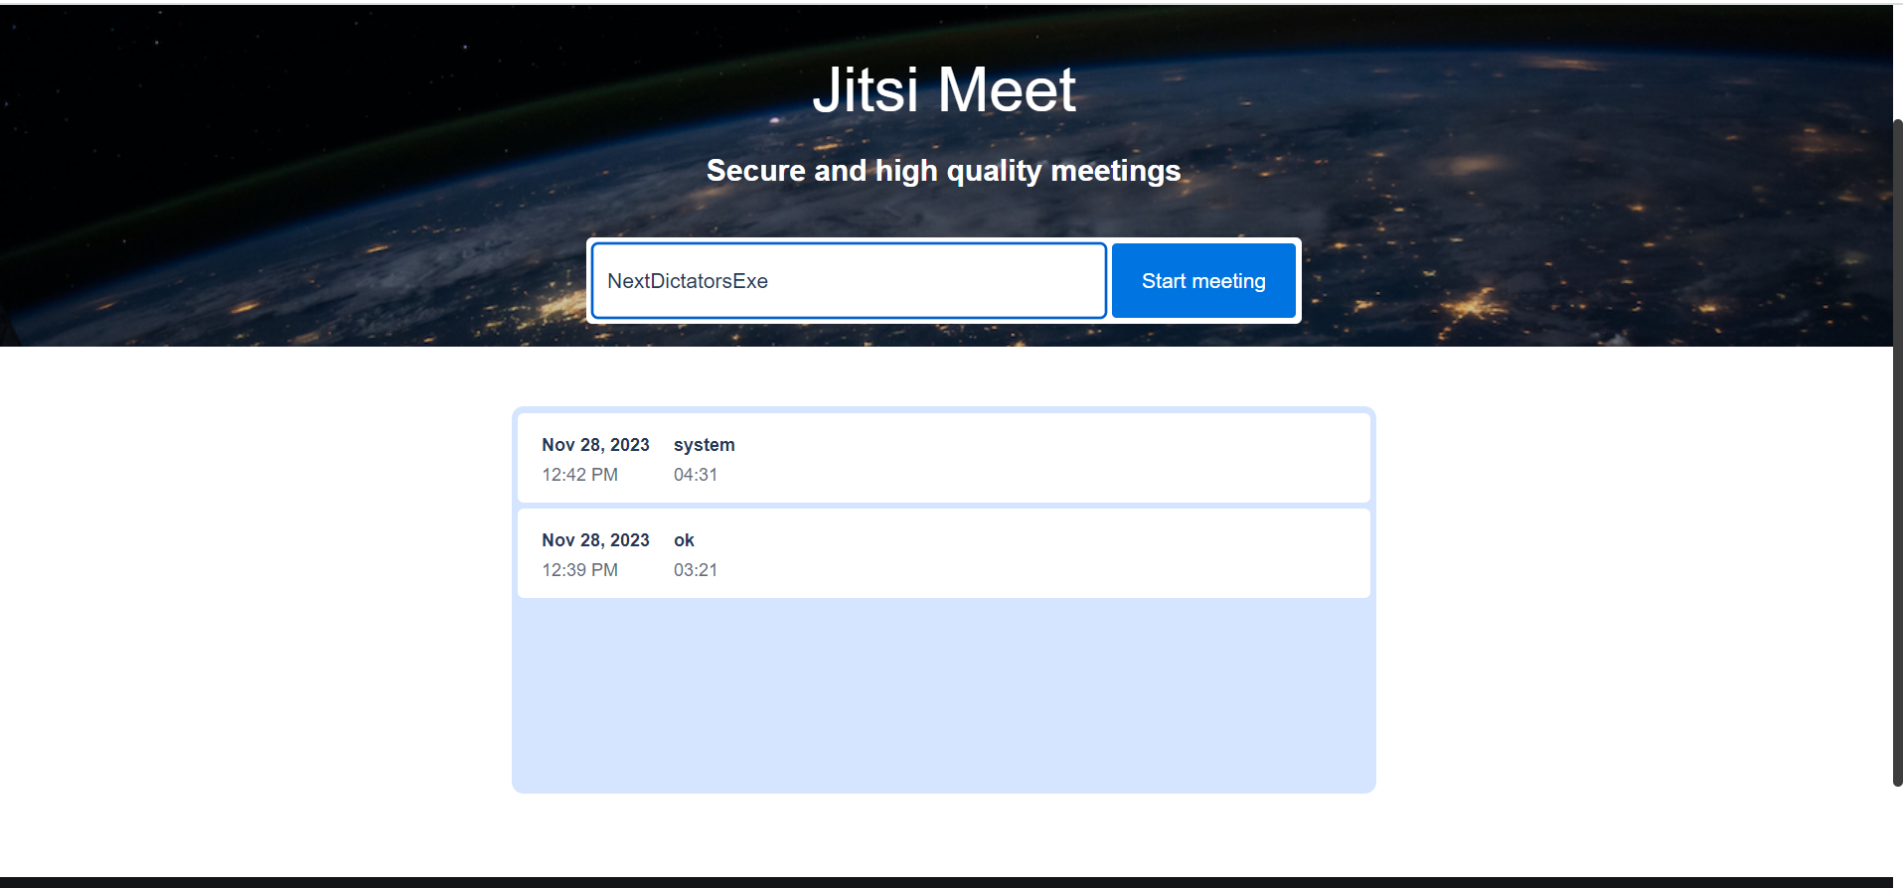

url: https://zivideo.mppolice.gov.in/system
user – 1st Test11
- It open an interface

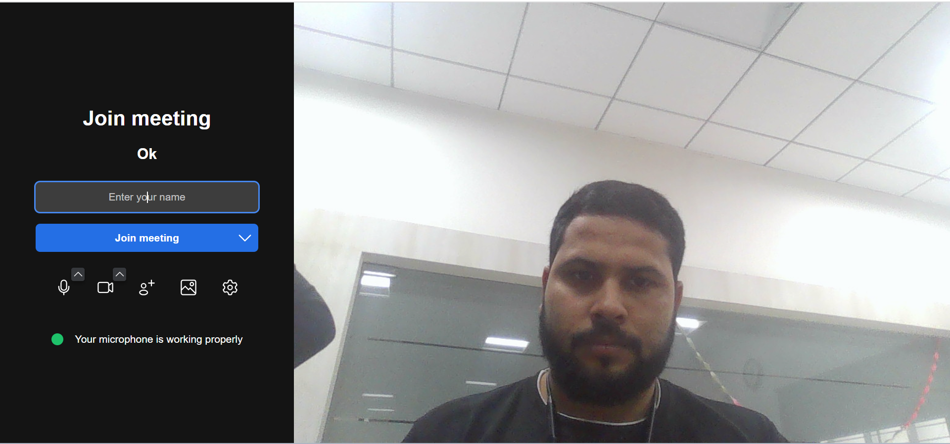

- Enter your name which you want to login

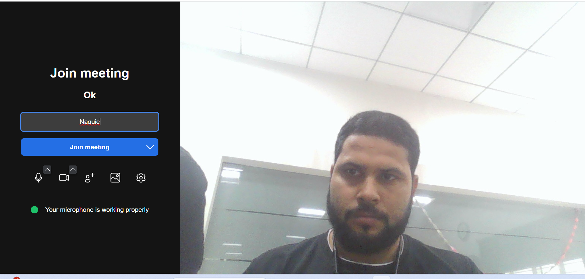

- Click on the log-in option

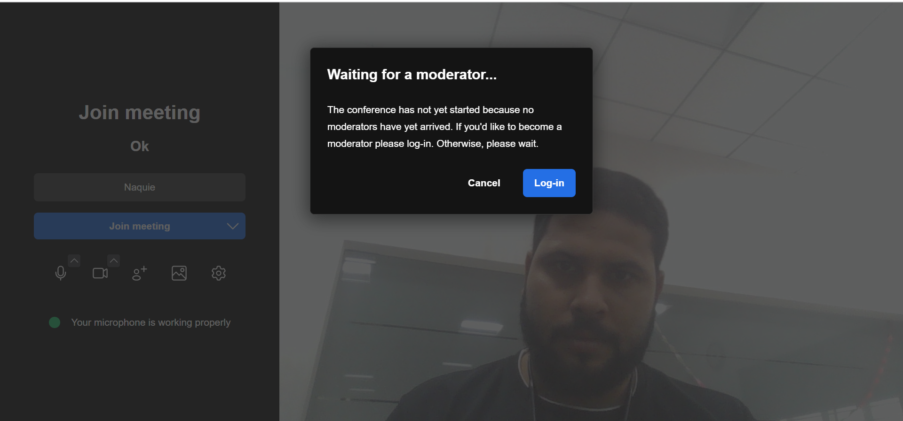

- Enter User name and User password to join the meeting

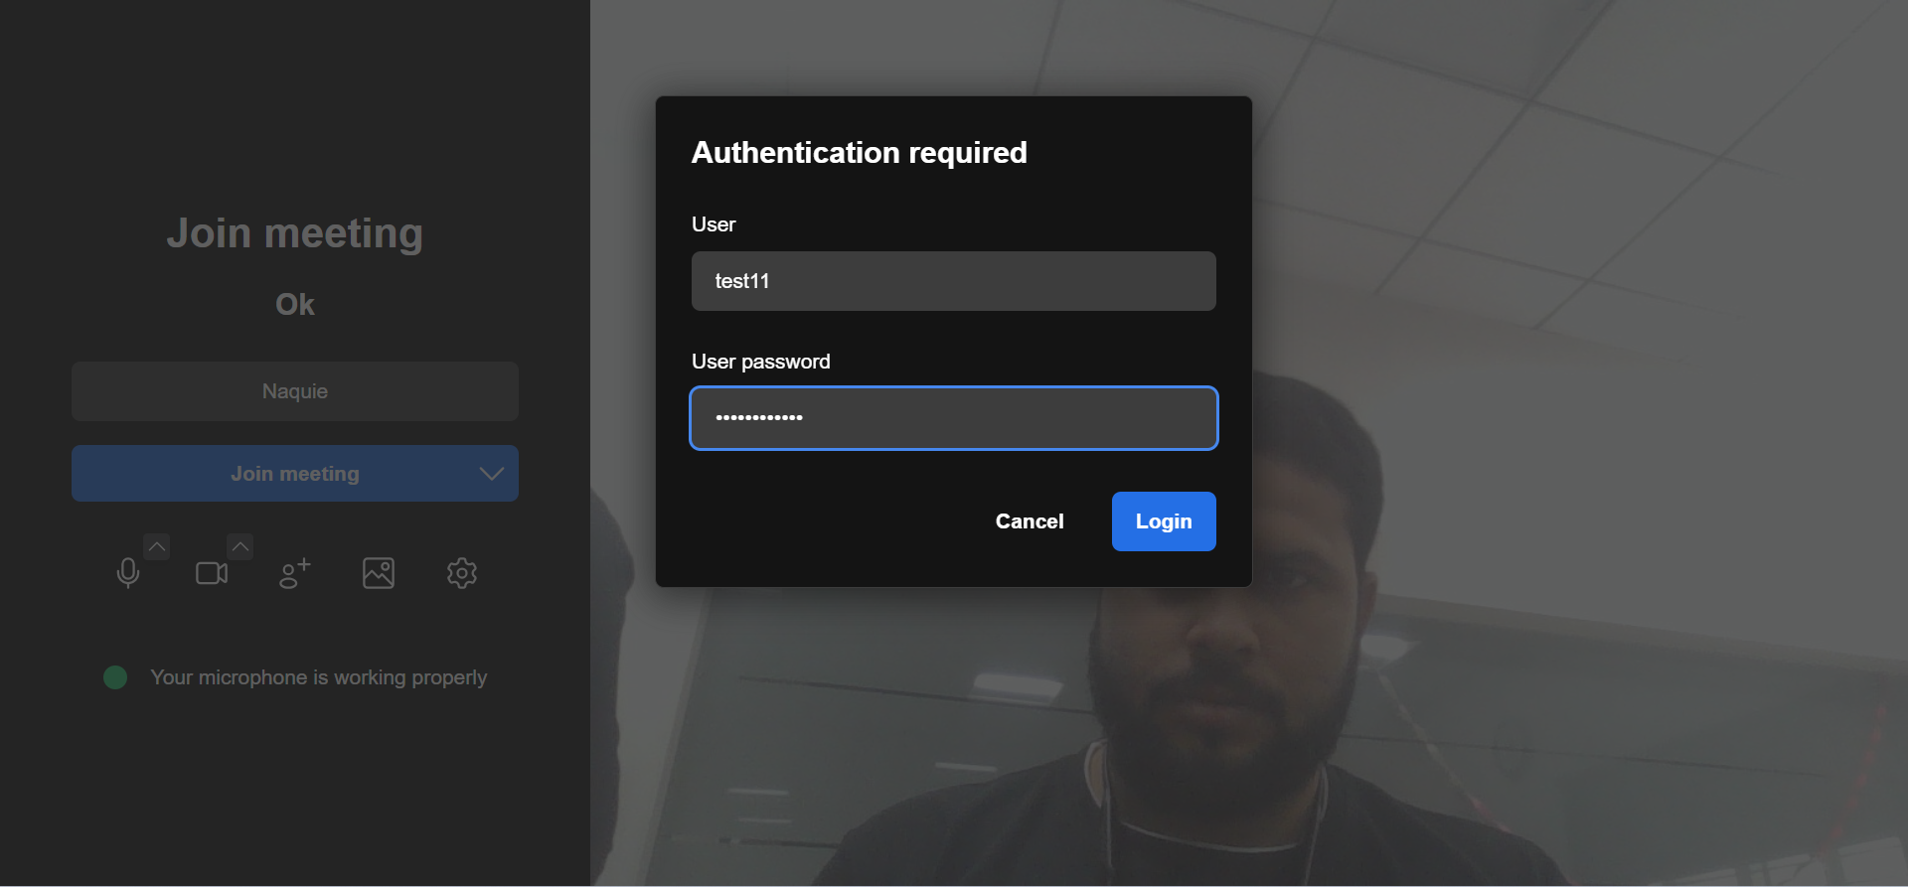

- Now we are able to do video conferencing

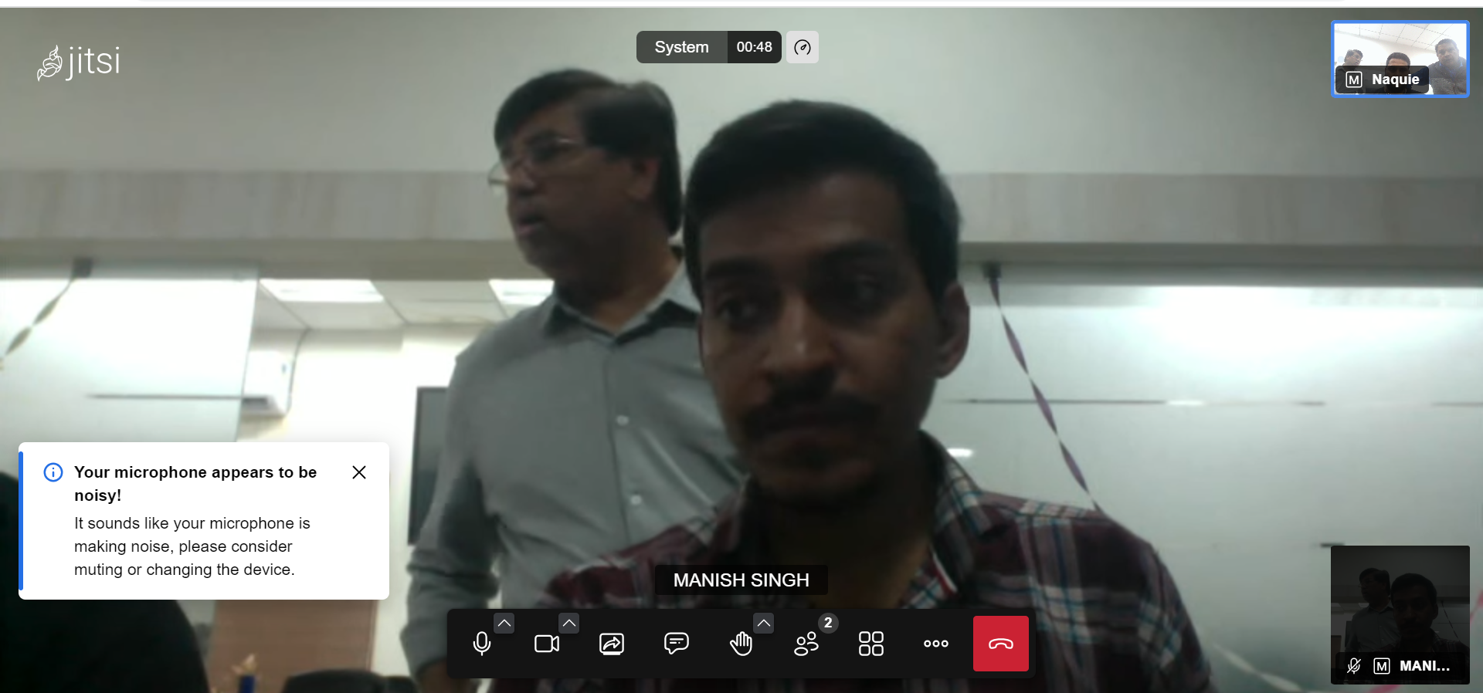

Note –
- Now can easily do video conferencing
- We can chat during video conferencing
- We can also record the video conferencing locally
- And much more feature are available.

