ELK Presentation Documentation

Url: https://10.1.1.228/

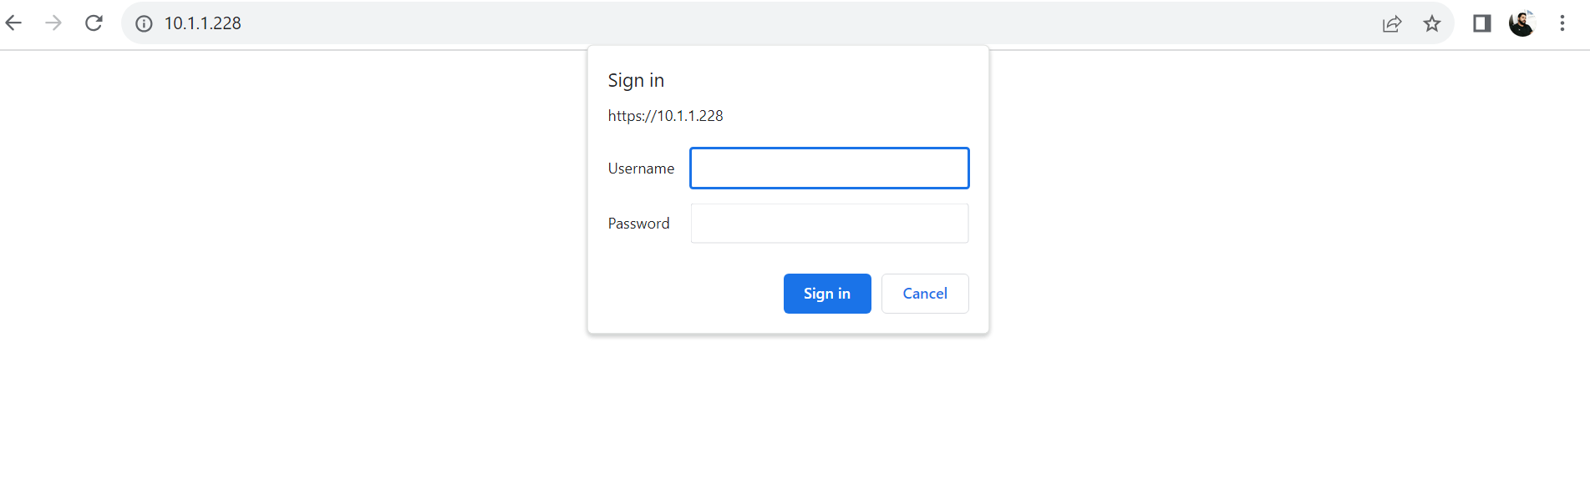
- Login through Username and Password

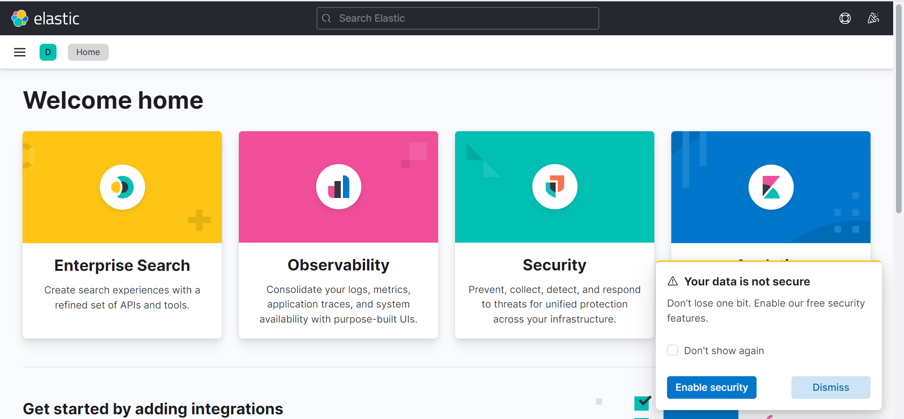

- Go to the Discover Option to see the Log
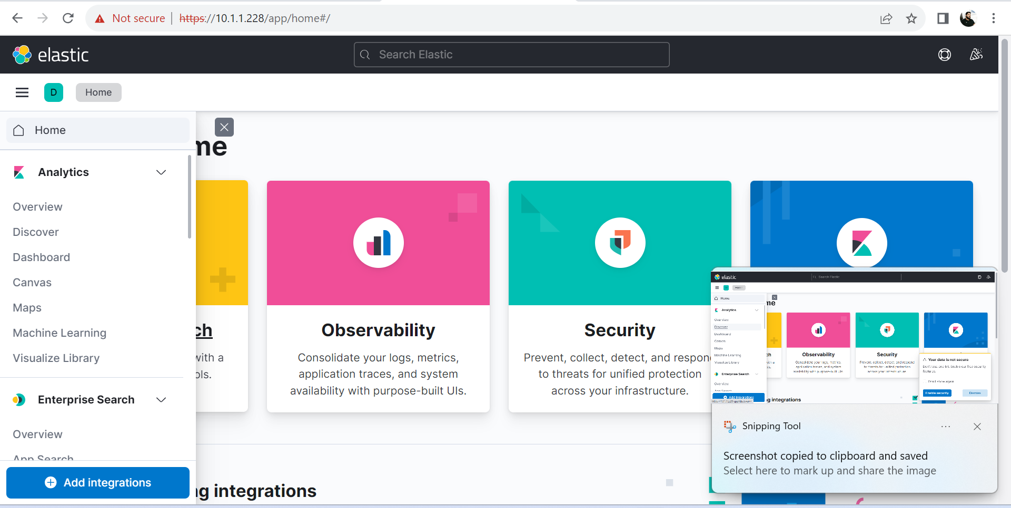
- Here log are visible
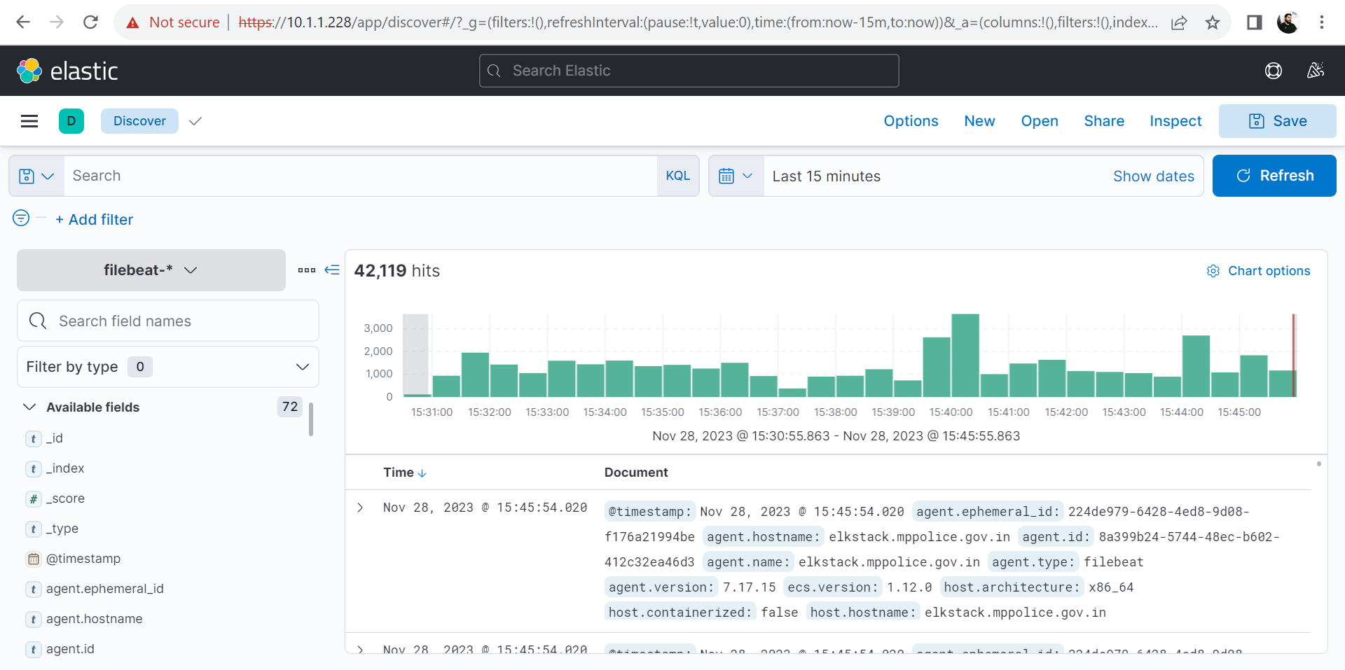

- To show the log of Particular Date

